X20 system certified for maritime use
After extensive testing by the certification institute Germanischer Lloyd (GL), the B&R X20 system has achieved the coveted seal of quality for maritime applications. All of the X20 modules tested – CPUs, I/O modules and bus controllers – proved they have what it takes to meet the high demands on functionality and operational safety required in maritime environments.
These components have been classified for environmental categories D and EMC1, which permits operation below deck, including in the bridge and engine room. As an internationally recognized certification organization, GL is involved in establishing technical standards for shipping and offshore facilities and is highly regarded by other classification societies such as ABS, Lloyds Register, DNV, Bureau Veritas, and many more.
In addition to the international prestige bestowed upon GL-certified components and the associated rapid approval procedures for shipping, the seal of quality provides comprehensive information regarding the safety and quality of industrial products. This seal is therefore not only significant in maritime applications, but also very respected in non-maritime environments. Users from a wide variety of different industries place a great amount of trust in this seal when deciding which products best suit their needs.
The X20 system is both a complete control solution as well as a remote I/O system. Its innovative three-part modularity – bus module, electronics module and terminal block – allows many different assemblies using a single platform. With its ultra-compact 8-channel, 12-channel and 16-channel modules, users can save up to 50% on their control cabinet solutions.

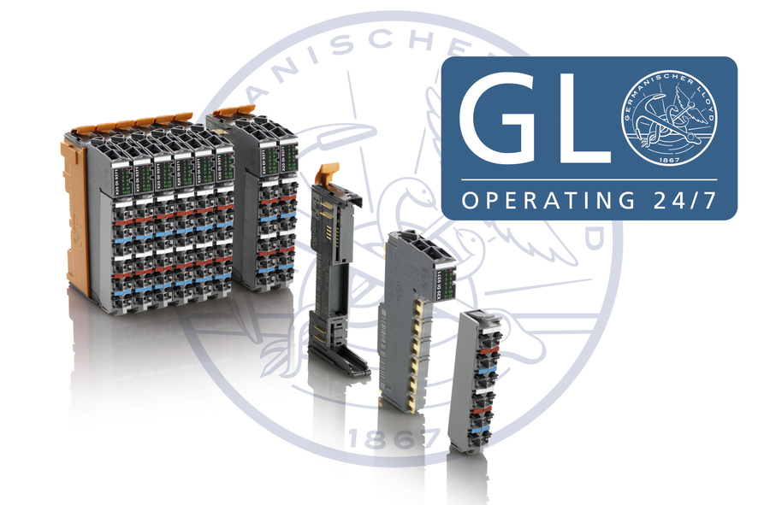
B&R's X20 system has received GL certification for use in maritime environments.

B&R Hakkında
ABB Grubunun bir bölümü olan B&R, merkezi Avusturya'da bulunan endüstriyel otomasyon alanında global bir liderdir. B&R, neredeyse her sektördeki müşterilere makine ve fabrika otomasyonu, hareket kontrolü, HMI ve entegre güvenlik teknolojisi için eksiksiz çözümler sunmak üzere en son teknolojiyi ileri mühendislikle birleştiriyor. OPC UA, POWERLINK ve openSAFETY gibi Endüstriyel IoT iletişim standartlarının yanı sıra Automation Studio yazılımıyla B&R, otomasyon mühendisliğinin geleceğini sürekli olarak yeniden tanımlıyor. B&R'ı endüstriyel otomasyonun ön saflarında tutan yenilikçi ruh, süreçleri basitleştirme ve müşteri beklentilerini aşma taahhüdünden kaynaklanmaktadır.
Daha fazla bilgi için www.br-automation.com adresini ziyaret edin.

