X20 System certified for maritime use
After extensive testing by the certification institute Germanischer Lloyd (GL), the B&R X20 System has achieved the coveted seal of quality for maritime applications. All of the X20 modules tested – CPUs, I/O modules and bus controllers – proved they have what it takes to meet the high demands on functionality and operational safety required in maritime environments.
These components have been classified for environmental categories D and EMC1, which permits operation below deck, including in the bridge and engine room. As an internationally recognized certification organization, GL is involved in establishing technical standards for shipping and offshore facilities and is highly regarded by other classification societies such as ABS, Lloyds Register, DNV, Bureau Veritas, and many more.
In addition to the international prestige bestowed upon GL-certified components and the associated rapid approval procedures for shipping, the seal of quality provides comprehensive information regarding the safety and quality of industrial products. This seal is therefore not only significant in maritime applications, but also very respected in non-maritime environments. Users from a wide variety of different industries place a great amount of trust in this seal when deciding which products best suit their needs.
The X20 System is both a complete control solution as well as a remote I/O system. 其创新的模块化设计由三部分组成 – 总线模块，电气模块和端子排 – 一个平台实现多个组件装配。With its ultra-compact 8-channel, 12-channel and 16-channel modules, users can save up to 50% on their control cabinet solutions.

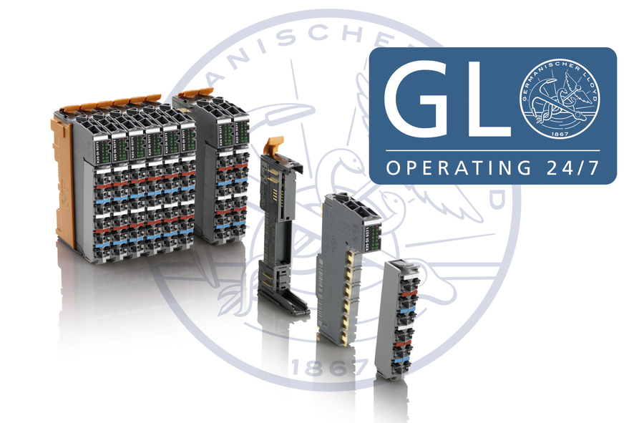
B&R's X20 System has received GL certification for use in maritime environments.

关于贝加莱
贝加莱是一家总部位于奥地利并在全球拥有分公司的创新型自动化企业。2017年7月，贝加莱成为ABB集团的机械自动化事业部。作为工业自动化领域的全球领导者，贝加莱将前沿技术与领先工程相结合，为几乎每个行业的客户提供面向机器与工厂自动化、运动控制、HMI和集成安全技术的完整解决方案。借助于OPC UA、POWERLINK、openSAFETY等工业物联网通信标准，以及强大的Automation Studio软件开发平台，贝加莱不断重新定义自动化工程的未来。受简化流程和超出客户预期的承诺驱动，贝加莱始终保持创新精神并处于工业自动化领域的前沿。
获取更多信息，请访问www.br-automation.com。

