Consortium including Airbus and the French National Railway Corporation define openSAFETY as standard
openSAFETY, the first completely open safety-oriented data transfer protocol for use in all areas of automation, has been declared an official communication standard by the DDASCA Consortium (Dependable Distributed Architecture for Safety Critical Applications). This consortium – formed in Paris in March 2011 on the initiative of Arion Entreprise, EADS, HPC Project, ENSTA, Alstom Power, EDF R&D, SNCF, Windriver, B&R, and others – handles the standardization, definition and implementation of open solutions for safety-critical applications up to SIL4. These solutions are then applied in a wide range of areas, from factory automation and energy management to the railway, automotive, medical and defense industries.
The DDASCA Consortium brings together suppliers, manufacturers, integrators, users and academics who are involved in applications that demand high levels of dependability. By selecting innovative safety technologies such as openSAFETY, the consortium continues to promote modular approaches based on scalable solutions that use open, standardized components.
openSAFETY on all bus systems
With openSAFETY, the EPSG offers the first 100% open safety protocol in the world. Its openness doesn't just come down to the legal definition, either; the word "open" applies in a technical sense as well. Thanks to the total independence of openSAFETY, users can use this technology for all fieldbus systems, industrial Ethernet applications or industry-specific communication solutions.

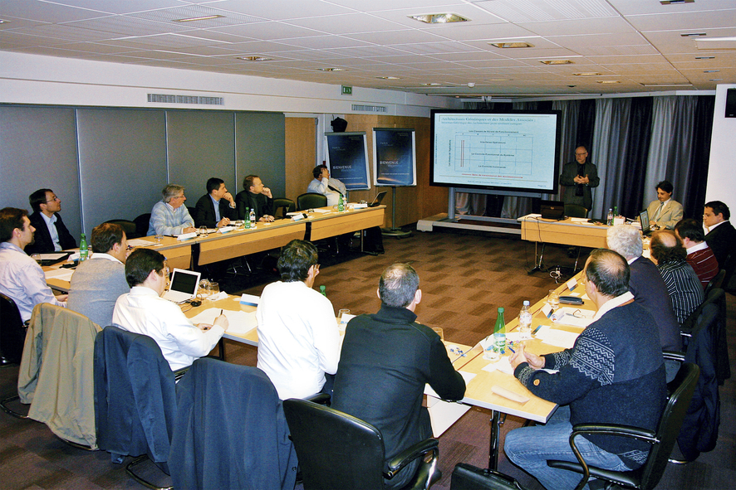
The founding meeting of the DDASCA Consortium in Paris brought together representatives from the aviation, aerospace, medical, and railway industries as well as the energy sector and leading research institutions.

About B&R
B&R, a division of ABB Group, is a global leader in industrial automation headquartered in Austria. B&R combines state-of-the-art technology with advanced engineering to provide customers in virtually every industry with complete solutions for machine and factory automation, motion control, HMI and integrated safety technology. With Industrial IoT communication standards including OPC UA, POWERLINK and openSAFETY as well as its Automation Studio software, B&R is constantly redefining the future of automation engineering. The innovative spirit that keeps B&R at the forefront of industrial automation is driven by a commitment to simplifying processes and exceeding customer expectations.
For more information, visit www.br-automation.com.

