Consortium including Airbus and the French National Railway Corporation define openSAFETY as standard
openSAFETY, the first completely open safety-oriented data transfer protocol for use in all areas of automation, has been declared an official communication standard by the DDASCA Consortium (Dependable Distributed Architecture for Safety Critical Applications). This consortium - formed in Paris in March 2011 on the initiative of Arion Entreprise, EADS, HPC Project, ENSTA, Alstom Power, EDF R&D, SNCF, Windriver, B&R, and others - handles the standardization, definition and implementation of open solutions for safety-critical applications up to SIL4. These solutions are then applied in a wide range of areas, from factory automation and energy management to the railway, automotive, medical and defense industries.
The DDASCA Consortium brings together suppliers, manufacturers, integrators, users and academics who are involved in applications that demand high levels of dependability. By selecting innovative safety technologies such as openSAFETY, the consortium continues to promote modular approaches based on scalable solutions that use open, standardized components.
openSAFETY on all bus systems
With openSAFETY, the EPSG offers the first 100% open safety protocol in the world. Its openness isn't restricted to just the legal definition, either; the word "open" applies in a technical sense as well. Thanks to the total independence of openSAFETY, users can use this technology for all fieldbus systems, industrial Ethernet applications or industry-specific communication solutions.

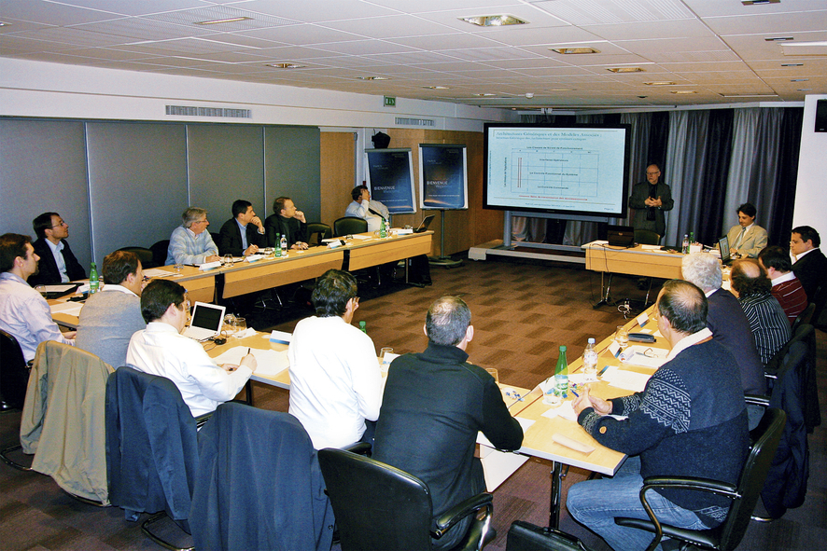
The founding meeting of the DDASCA Consortium in Paris brought together representatives from the aviation, aerospace, medical, and railway industries as well as the energy sector and leading research institutions.

Acerca de B&R
B&R, empresa perteneciente al Grupo ABB y con sede en Austria, es líder mundial en automatización industrial. B&R combina tecnología de vanguardia con ingeniería avanzada para proporcionar a usuarios de todos los sectores soluciones completas para la automatización de máquinas y fábricas, Motion Control, HMI y tecnología de seguridad integrada. El catálogo de productos se completa con estándares de comunicación de IoT industrial que incluyen OPC UA, POWERLINK y openSAFETY. Gracias a su única herramienta de software Automation Studio, B&R redefine constantemente el futuro de la ingeniería de automatización. El espíritu innovador que mantiene a B&R a la vanguardia de la automatización industrial está impulsado por el compromiso de simplificar los procesos y superar las expectativas de los clientes.Para más información, visite www.br-automation.com.
Para más información, visite www.br-automation.com.

