Consortium including Airbus and the French National Railway Corporation define openSAFETY as standard
openSAFETY, the first completely open safety-oriented data transfer protocol for use in all areas of automation, has been declared an official communication standard by the DDASCA Consortium (Dependable Distributed Architecture for Safety Critical Applications). This consortium – formed in Paris in March 2011 on the initiative of Arion Entreprise, EADS, HPC Project, ENSTA, Alstom Power, EDF R&D, SNCF, Windriver, B&R, and others – handles the standardization, definition and implementation of open solutions for safety-critical applications up to SIL4. These solutions are then applied in a wide range of areas, from factory automation and energy management to the railway, automotive, medical and defense industries.
The DDASCA Consortium brings together suppliers, manufacturers, integrators, users and academics who are involved in applications that demand high levels of dependability. By selecting innovative safety technologies such as openSAFETY, the consortium continues to promote modular approaches based on scalable solutions that use open, standardized components.
openSAFETY on all bus systems
With openSAFETY, the EPSG offers the first 100% open safety protocol in the world. Its openness doesn't just come down to the legal definition, either; the word "open" applies in a technical sense as well. Thanks to the total independence of openSAFETY, users can use this technology for all fieldbus systems, industrial Ethernet applications or industry-specific communication solutions.

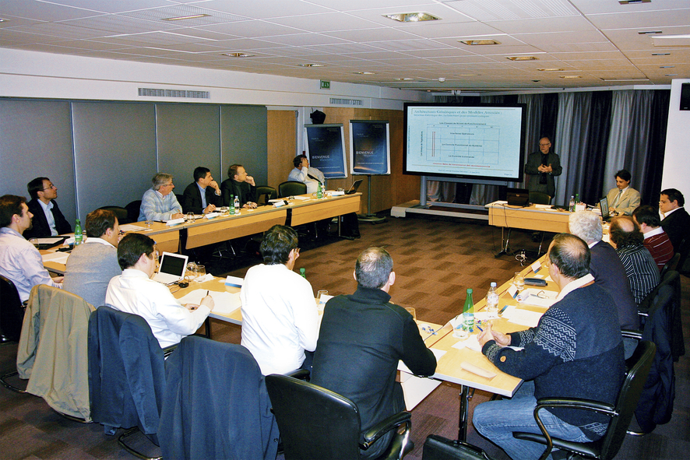
The founding meeting of the DDASCA Consortium in Paris brought together representatives from the aviation, aerospace, medical, and railway industries as well as the energy sector and leading research institutions.

B&R Hakkında
ABB Grubunun bir bölümü olan B&R, merkezi Avusturya'da bulunan endüstriyel otomasyon alanında global bir liderdir. B&R, neredeyse her sektördeki müşterilere makine ve fabrika otomasyonu, hareket kontrolü, HMI ve entegre güvenlik teknolojisi için eksiksiz çözümler sunmak üzere en son teknolojiyi ileri mühendislikle birleştiriyor. OPC UA, POWERLINK ve openSAFETY gibi Endüstriyel IoT iletişim standartlarının yanı sıra Automation Studio yazılımıyla B&R, otomasyon mühendisliğinin geleceğini sürekli olarak yeniden tanımlıyor. B&R'ı endüstriyel otomasyonun ön saflarında tutan yenilikçi ruh, süreçleri basitleştirme ve müşteri beklentilerini aşma taahhüdünden kaynaklanmaktadır.
Daha fazla bilgi için www.br-automation.com adresini ziyaret edin.

