Consortium including Airbus and the French National Railway Corporation define openSAFETY as standard
openSAFETY, the first completely open safety-oriented data transfer protocol for use in all areas of automation, has been declared an official communication standard by the DDASCA Consortium (Dependable Distributed Architecture for Safety Critical Applications). This consortium - formed in Paris in March 2011 on the initiative of Arion Entreprise, EADS, HPC Project, ENSTA, Alstom Power, EDF R&D, SNCF, Windriver, B&R, and others - handles the standardization, definition and implementation of open solutions for safety-critical applications up to SIL4. These solutions are then applied in a wide range of areas, from factory automation and energy management to the railway, automotive, medical and defense industries.
The DDASCA Consortium brings together suppliers, manufacturers, integrators, users and academics who are involved in applications that demand high levels of dependability. By selecting innovative safety technologies such as openSAFETY, the consortium continues to promote modular approaches based on scalable solutions that use open, standardized components.
openSAFETY on all bus systems
With openSAFETY, the EPSG offers the first 100% open safety protocol in the world. Its openness isn't restricted to just the legal definition, either; the word "open" applies in a technical sense as well. Thanks to the total independence of openSAFETY, users can use this technology for all fieldbus systems, industrial Ethernet applications or industry-specific communication solutions.

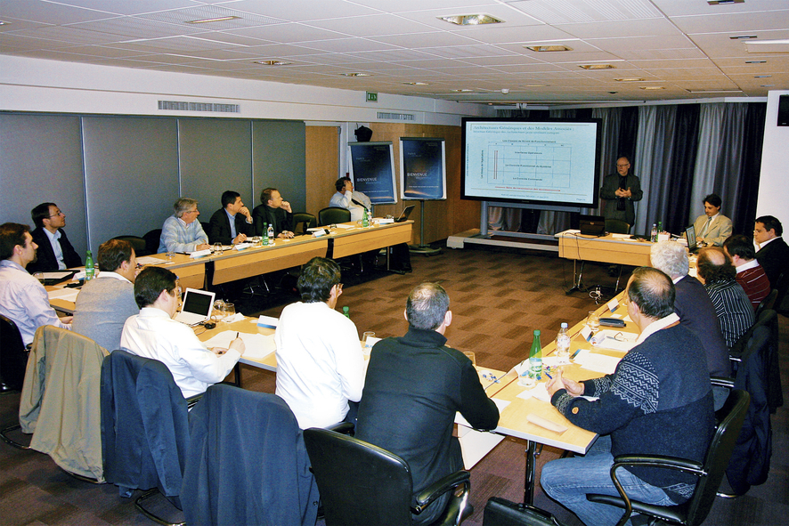
The founding meeting of the DDASCA Consortium in Paris brought together representatives from the aviation, aerospace, medical, and railway industries as well as the energy sector and leading research institutions.

关于贝加莱
贝加莱是一家总部位于奥地利并在全球拥有分公司的创新型自动化企业。2017年7月，贝加莱成为ABB集团的机械自动化事业部。作为工业自动化领域的全球领导者，贝加莱将前沿技术与领先工程相结合，为几乎每个行业的客户提供面向机器与工厂自动化、运动控制、HMI和集成安全技术的完整解决方案。借助于OPC UA、POWERLINK、openSAFETY等工业物联网通信标准，以及强大的Automation Studio软件开发平台，贝加莱不断重新定义自动化工程的未来。受简化流程和超出客户预期的承诺驱动，贝加莱始终保持创新精神并处于工业自动化领域的前沿。
获取更多信息，请访问www.br-automation.com。

