Automation Studio is one of the most widely used engineering tools in the industry
According to a recent study published by ITQ in cooperation with universities and the trade magazine Computer&AUTOMATION, 16% of all German machine and system manufacturers are already programming their control systems using Automation Studio.As a result, nearly one in six German machine manufacturers are working with the B&R software tool.
The analysis of the survey also points out that controller hardware is now no longer the sole criteria when making a decision and that the engineering environment provided by the manufacturer is becoming increasingly important. This indicates a significant change for machine and system manufacturing as more and more companies place their trust in integrated software development environments such as Automation Studio to manage the increasing complexity of industrial automation tasks.
Survey respondents listed factors such as intuitive program operation, software quality assurance and the ability to port existing software as having high priority. 92% were adamant about the importance of reusing existing software in light of the fact that companies are now placing a very large portion of their expertise into the software they develop.
Efficient and sustainable development with Automation Studio 4
With Automation Studio 4, B&R offers even smarter development methods for machine and system manufacturing in the form of a fully integrated tool. Working simultaneously on different tasks and dividing individual projects into modules not only increases efficiency, it also reduces time to market. Reusing software in subsequent machine generations also ensures a maximum return on investment.
More information concerning the study can be found on the Computer&AUTOMATION website at www.computer-automation.de.

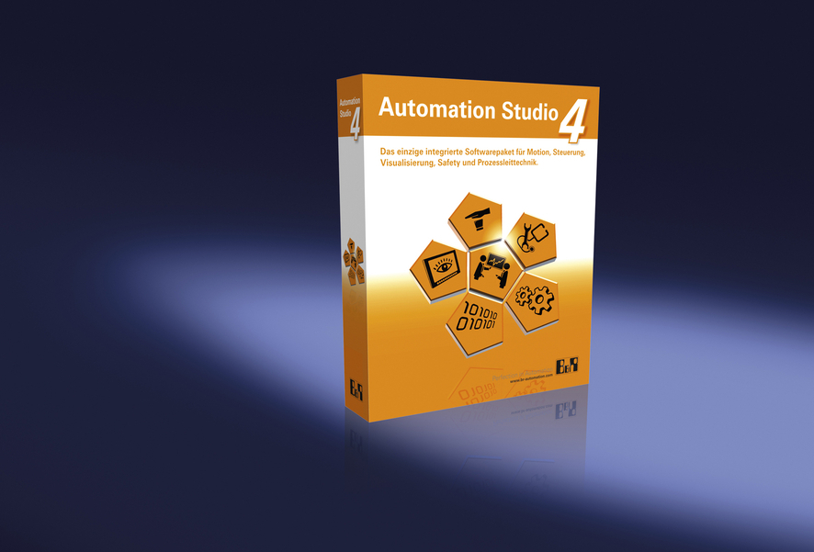
16% of all German machine manufacturers use B&R Automation Studio.

Acerca de B&R
B&R, empresa perteneciente al Grupo ABB y con sede en Austria, es líder mundial en automatización industrial. B&R combina tecnología de vanguardia con ingeniería avanzada para proporcionar a usuarios de todos los sectores soluciones completas para la automatización de máquinas y fábricas, Motion Control, HMI y tecnología de seguridad integrada. El catálogo de productos se completa con estándares de comunicación de IoT industrial que incluyen OPC UA, POWERLINK y openSAFETY. Gracias a su única herramienta de software Automation Studio, B&R redefine constantemente el futuro de la ingeniería de automatización. El espíritu innovador que mantiene a B&R a la vanguardia de la automatización industrial está impulsado por el compromiso de simplificar los procesos y superar las expectativas de los clientes.Para más información, visite www.br-automation.com.
Para más información, visite www.br-automation.com.

