Automation Studio is one of the most widely used engineering tools in the industry
According to a recent study published by ITQ in cooperation with universities and the trade magazine Computer&AUTOMATION, 16% of all German machine and system manufacturers are already programming their control systems using Automation Studio.As a result, nearly one in six German machine manufacturers are working with the B&R software tool.
The analysis of the survey also points out that controller hardware is now no longer the sole criteria when making a decision and that the engineering environment provided by the manufacturer is becoming increasingly important. This indicates a significant change for machine and system manufacturing as more and more companies place their trust in integrated software development environments such as Automation Studio to manage the increasing complexity of industrial automation tasks.
Survey respondents listed factors such as intuitive program operation, software quality assurance and the ability to port existing software as having high priority. 92% were adamant about the importance of reusing existing software in light of the fact that companies are now placing a very large portion of their expertise into the software they develop.
Efficient and sustainable development with Automation Studio 4
With Automation Studio 4, B&R offers even smarter development methods for machine and system manufacturing in the form of a fully integrated tool. Working simultaneously on different tasks and dividing individual projects into modules not only increases efficiency, it also reduces time to market. Reusing software in subsequent machine generations also ensures a maximum return on investment.
More information concerning the study can be found on the Computer&AUTOMATION website at www.computer-automation.de.

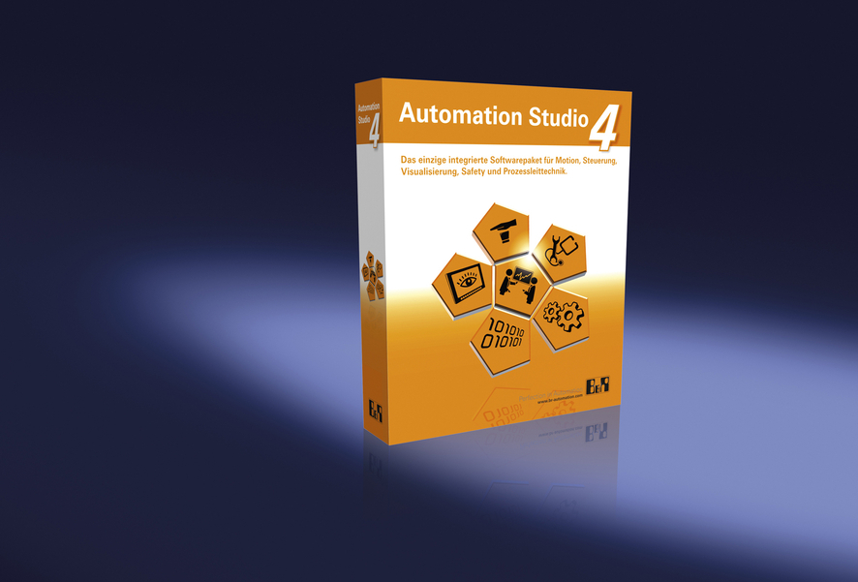
16% of all German machine manufacturers use B&R Automation Studio.

关于贝加莱
贝加莱是一家总部位于奥地利并在全球拥有分公司的创新型自动化企业。2017年7月，贝加莱成为ABB集团的机械自动化事业部。作为工业自动化领域的全球领导者，贝加莱将前沿技术与领先工程相结合，为几乎每个行业的客户提供面向机器与工厂自动化、运动控制、HMI和集成安全技术的完整解决方案。借助于OPC UA、POWERLINK、openSAFETY等工业物联网通信标准，以及强大的Automation Studio软件开发平台，贝加莱不断重新定义自动化工程的未来。受简化流程和超出客户预期的承诺驱动，贝加莱始终保持创新精神并处于工业自动化领域的前沿。
获取更多信息，请访问www.br-automation.com。

