New dimensions in decentralized drive architecture
B&R is expanding their line of drives with a series of motor-mounted servo drives with IP65 protection. The ACOPOSmulti has always been extremely modular, and it was the next logical step to merge inverters with the motor to create servo actuators that can deliver power directly where it is needed. Configurable modules thus become easy-to-connect mechatronic units. This not only saves valuable space in the control cabinet, but also cuts costs for logistics and commissioning.
This new system unites all of the important components such as the motor, positioning sensor (encoder), precision gearbox and servo drive into a very compact unit. Thanks to the simple electrical connection, the ACOPOSmulti65m supports the implementation of modular machine concepts, thus making it possible to efficiently design optimized manufacturing strategies. "With the new servo actuator, we are continuing on the path to decentralized motion control," explains Alois Holzleitner, manager of B&R's Motion business unit. "We now offer the entire drive spectrum – from frequency inverters and multi-axis servo drives to decentralized drive solutions – all from a single source."
By combining the latest IGBT technology and optimized motor types, users profit from the resulting maximum performance. With three different sizes, the servo actuators cover the entire spectrum, with a torque range of 1.8 to 10.5 Nm and a power range of 500 W to 2 kW. For applications that demand more power, an optional fan assembly can be retrofitted for a performance boost of up to 100%.
100% compatibility with B&R drive systems
The ACOPOSmulti65m is fully compatible with the entire ACOPOS drive series. As a result, it is possible to utilize all of the tools and features available in Automation Studio as well as applications created therein. With regard to topology, the new servo actuator can be employed in either a line or tree structure. Networking takes place using POWERLINK.
In addition, it comes equipped with STO (Safe Torque Off) and SS1 safety functions in accordance with SIL 3 or PLe. Additional safety functions such as SLS, SOS, SDI, SLP and many more can be used in combination with openSAFETY and are an integral component of the ACOPOSmotor with SafeMOTION.

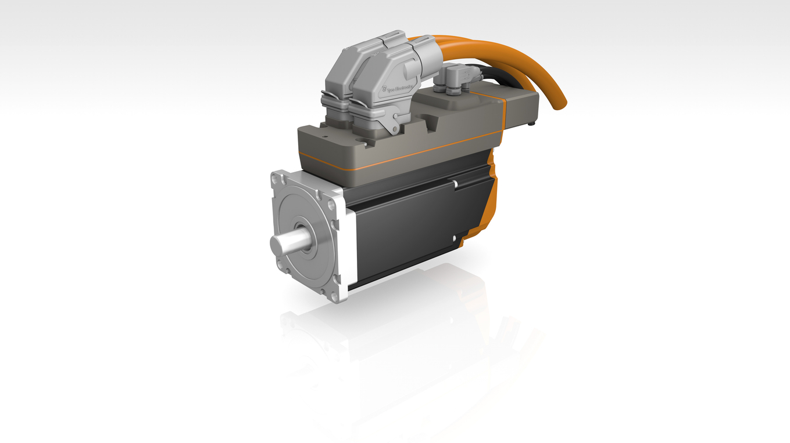
Safe Motion Control comes standard in the new motor-integrated ACOPOSmulti65m servo actuator.

B&R Hakkında
ABB Grubunun bir bölümü olan B&R, merkezi Avusturya'da bulunan endüstriyel otomasyon alanında global bir liderdir. B&R, neredeyse her sektördeki müşterilere makine ve fabrika otomasyonu, hareket kontrolü, HMI ve entegre güvenlik teknolojisi için eksiksiz çözümler sunmak üzere en son teknolojiyi ileri mühendislikle birleştiriyor. OPC UA, POWERLINK ve openSAFETY gibi Endüstriyel IoT iletişim standartlarının yanı sıra Automation Studio yazılımıyla B&R, otomasyon mühendisliğinin geleceğini sürekli olarak yeniden tanımlıyor. B&R'ı endüstriyel otomasyonun ön saflarında tutan yenilikçi ruh, süreçleri basitleştirme ve müşteri beklentilerini aşma taahhüdünden kaynaklanmaktadır.
Daha fazla bilgi için www.br-automation.com adresini ziyaret edin.

