New dimensions in decentralized drive architecture
B&R is expanding their line of drives with a series of motor-integrated servo drives with IP65 protection. The ACOPOSmulti has always been extremely modular, and it was the next logical step to merge inverters with the motor to create servo actuators that can deliver power directly where it is needed. Configurable modules thus become easy-to-connect mechatronic units. This not only saves valuable space in the control cabinet, but also cuts costs for logistics and commissioning.
This new system unites all of the important components such as the motor, positioning sensor (encoder), precision gearbox and servo drive into a very compact unit. Thanks to the simple electrical connection, the ACOPOSmulti65m supports the implementation of modular machine concepts, thus making it possible to efficiently design optimized manufacturing strategies. "With the new servo actuator, we are continuing on the path to decentralized motion control," explains Alois Holzleitner, Business Unit Manager of Motion at B&R. "We now offer the entire drive spectrum - from variable frequency drives and multi-axis servo drives to decentralized drive solutions - all from a single source."
By combining the latest IGBT technology and optimized motor types, users profit from the resulting maximum performance. 伺服执行机构拥有三种不同的尺寸，扭矩范围从1.8至10.5 Nm，功率范围从500 W至2 kW。For applications that demand more power, an optional fan assembly can be retrofitted for a performance boost of up to 100%.
100% compatibility with B&R drive systems
The ACOPOSmulti65m is fully compatible with the entire ACOPOS drive series. As a result, it is possible to utilize all of the tools and features available in Automation Studio as well as applications created therein. With regard to topology, the new servo actuator can be employed in either a line or tree structure. Networking takes place using POWERLINK.
In addition, it comes equipped with STO (Safe Torque Off) and SS1 safety functions in accordance with SIL 3 or PLe. Additional safety functions such as SLS, SOS, SDI, SLP and many more can be used in combination with openSAFETY and are an integral component of the ACOPOSmulti65m model with SafeMC.

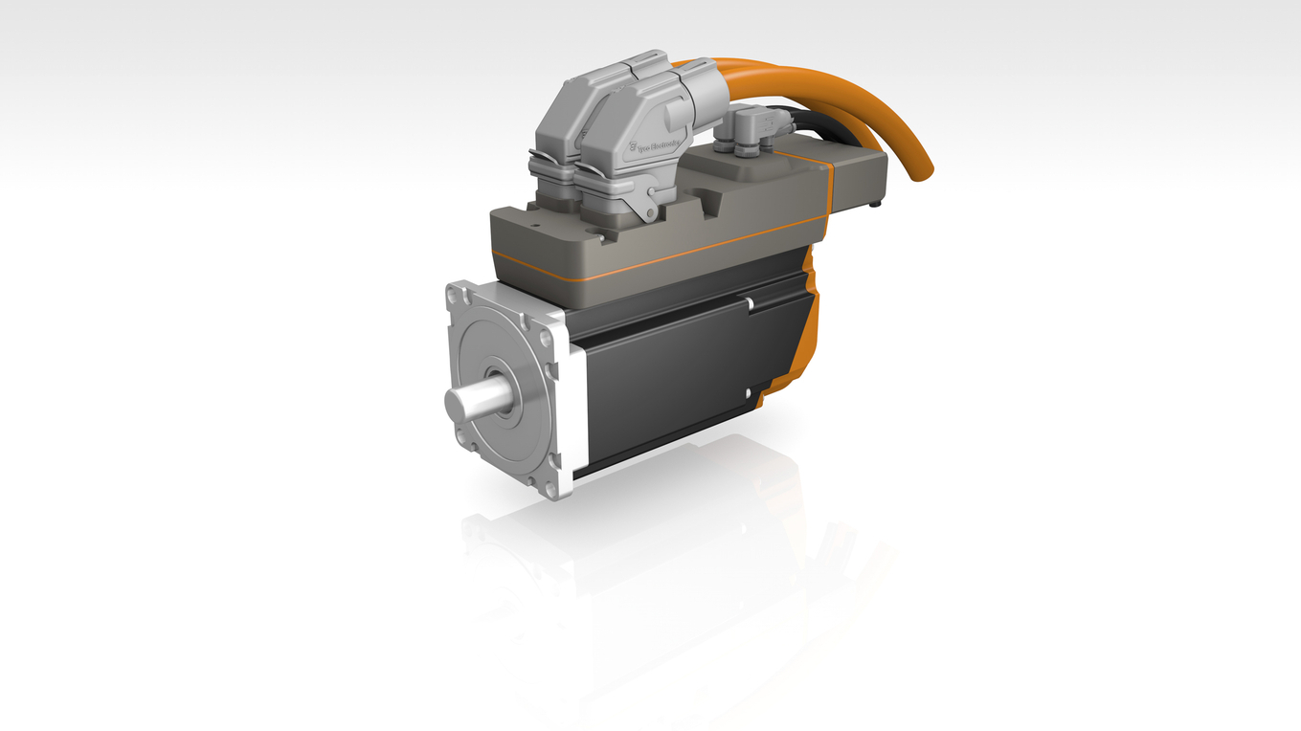
Safe Motion Control comes standard in the new motor-integrated ACOPOSmulti65m servo actuator.

关于贝加莱
贝加莱是一家总部位于奥地利并在全球拥有分公司的创新型自动化企业。2017年7月，贝加莱成为ABB集团的机械自动化事业部。作为工业自动化领域的全球领导者，贝加莱将前沿技术与领先工程相结合，为几乎每个行业的客户提供面向机器与工厂自动化、运动控制、HMI和集成安全技术的完整解决方案。借助于OPC UA、POWERLINK、openSAFETY等工业物联网通信标准，以及强大的Automation Studio软件开发平台，贝加莱不断重新定义自动化工程的未来。受简化流程和超出客户预期的承诺驱动，贝加莱始终保持创新精神并处于工业自动化领域的前沿。
获取更多信息，请访问www.br-automation.com。

