POWERLINK bus controller – Perfect fit for any application
The extremely flexible configuration possibilities offered by B&R's new POWERLINK X67 bus controller with IP67 protection make it an indispensable standard component for any demanding automation application. Equipped with 12 digital channels that can be configured as either inputs or outputs, the module can be perfectly adapted to any task.
An analog channel for 0 to 20 mA further extends the range of potential applications for the POWERLINK bus controller. The freely configurable input filter provides additional flexibility for project implementation. Furthermore, one input can be used as a counter input for an event counter. All connections are designed for standard M12 connectors.
The POWERLINK module has two network connectors, making daisy chain wiring a further possibility.
Flexible expansion
Thanks to the remote backplane, the POWERLINK bus controller can be expanded to include additional X67 or X20 modules over long distances. The user enjoys virtually unlimited system design freedom.

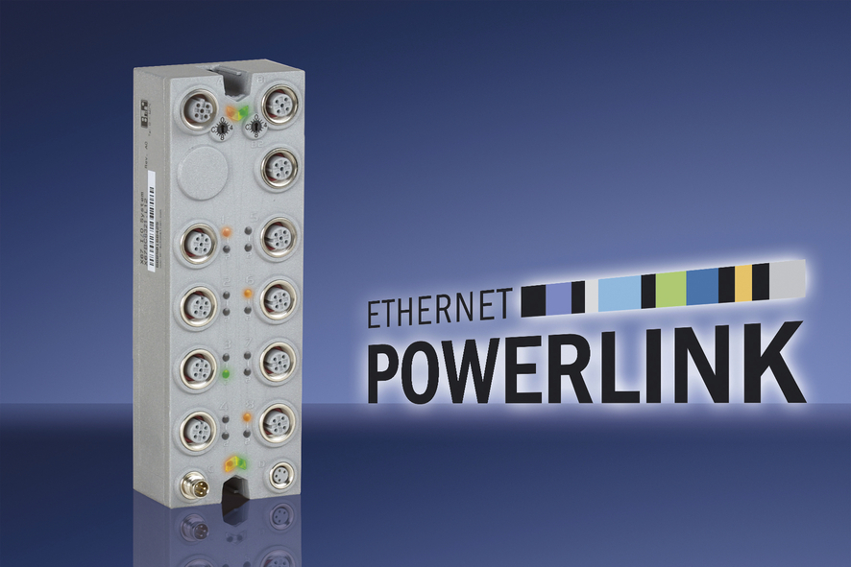
The new POWERLINK X67 bus controller from B&R offers users virtually unlimited freedom in system design.

About B&R
B&R, a division of ABB Group, is a global leader in industrial automation headquartered in Austria. B&R combines state-of-the-art technology with advanced engineering to provide customers in virtually every industry with complete solutions for machine and factory automation, motion control, HMI and integrated safety technology. With Industrial IoT communication standards including OPC UA, POWERLINK and openSAFETY as well as its Automation Studio software, B&R is constantly redefining the future of automation engineering. The innovative spirit that keeps B&R at the forefront of industrial automation is driven by a commitment to simplifying processes and exceeding customer expectations.
For more information, visit www.br-automation.com.

