POWERLINK bus controller: Tailored to any application
The extremely flexible configuration options offered by B&R's new POWERLINK X67 bus controller with IP67 protection make it an indispensable standard component for any demanding automation application. Equipped with 12 digital channels that can be configured as either inputs or outputs, the module can be perfectly adapted to any task.
An analog channel for 0 to 20 mA further extends the range of potential applications for the POWERLINK bus controller. The freely configurable input filter provides additional flexibility for project implementation. Furthermore, one input can be used as a counter input for an event counter. All connections are designed for M12 standard plugs.
The POWERLINK module has two network connectors, making daisy chain wiring a further possibility.
灵活的扩展
Thanks to the remote backplane, the POWERLINK bus controller can be expanded to include additional X67 or X20 modules over long distances. The user enjoys virtually unlimited system design freedom.

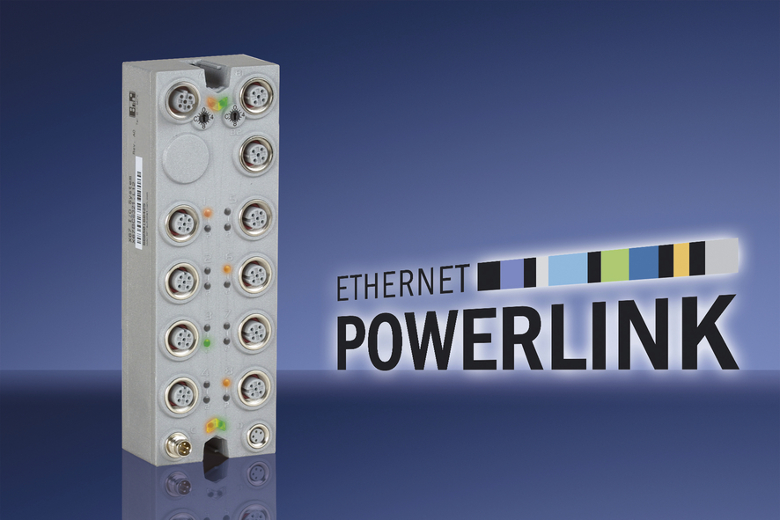
The new POWERLINK X67 bus controller from B&R offers users virtually unlimited freedom in system design.

关于贝加莱
贝加莱是一家总部位于奥地利并在全球拥有分公司的创新型自动化企业。2017年7月，贝加莱成为ABB集团的机械自动化事业部。作为工业自动化领域的全球领导者，贝加莱将前沿技术与领先工程相结合，为几乎每个行业的客户提供面向机器与工厂自动化、运动控制、HMI和集成安全技术的完整解决方案。借助于OPC UA、POWERLINK、openSAFETY等工业物联网通信标准，以及强大的Automation Studio软件开发平台，贝加莱不断重新定义自动化工程的未来。受简化流程和超出客户预期的承诺驱动，贝加莱始终保持创新精神并处于工业自动化领域的前沿。
获取更多信息，请访问www.br-automation.com。

