Smart Safe Reaction with openSAFETY for Profinet
Now that B&R's SafeLOGIC safety controller is available for Profinet networks, Smart Safe Reaction technology can be quickly and easily integrated into Profinet automation applications. Based on openSAFETY, B&R's Smart Safe Reaction product set is the only integrated safety system that can guarantee response times of 10 ms. This is 10 times faster than previous solutions. The openSAFETY real-time safety bus system is not bound to a single solution and can be used on all conventional Ethernet-based fieldbus network systems up to SIL 3.
In industries where Profinet has established itself as the most prevalent fieldbus network, there is considerable interest in open safety technology. With the innovative and high-performance features that Smart Safe Reaction technology can provide in combination with openSAFETY, user requirements can now also be solved on automated machines and systems that use Profinet.
Product set for Profinet
B&R meets this demand with a SafeLOGIC safety controller model for Profinet. It allows execution of the safety-related application program and also handles monitoring the overall configuration of the application, including its parameters.
The application on the Profinet master CPU has full access to the signals in the network, regardless of whether standard or safety-related channels are affected. The SafeLOGIC controller also uses openSAFETY to monitor the system and shut it down if a safety requirement is not met. A wide range of proven functions from the Smart Safe Reaction portfolio is available for implementation. This includes, for example, PLCopen-compliant and TÜV-certified function blocks, secure digital and analog input signals, safe temperature signal detection, and much more.
Putting the "open" in openSAFETY
The SafeLOGIC controller in this network can of course also handle signals from openSAFETY components such as light grids, laser scanners and frequency inverters from other manufacturers.

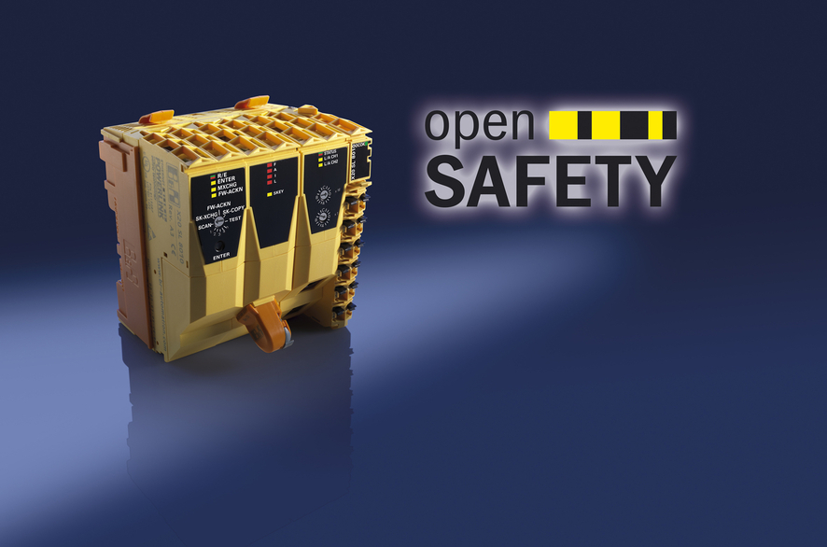
The new SafeLOGIC model from B&R allows Smart Safe Reaction technology to be used together with Profinet.

B&R Hakkında
ABB Grubunun bir bölümü olan B&R, merkezi Avusturya'da bulunan endüstriyel otomasyon alanında global bir liderdir. B&R, neredeyse her sektördeki müşterilere makine ve fabrika otomasyonu, hareket kontrolü, HMI ve entegre güvenlik teknolojisi için eksiksiz çözümler sunmak üzere en son teknolojiyi ileri mühendislikle birleştiriyor. OPC UA, POWERLINK ve openSAFETY gibi Endüstriyel IoT iletişim standartlarının yanı sıra Automation Studio yazılımıyla B&R, otomasyon mühendisliğinin geleceğini sürekli olarak yeniden tanımlıyor. B&R'ı endüstriyel otomasyonun ön saflarında tutan yenilikçi ruh, süreçleri basitleştirme ve müşteri beklentilerini aşma taahhüdünden kaynaklanmaktadır.
Daha fazla bilgi için www.br-automation.com adresini ziyaret edin.

