Smart Safe Reaction with openSAFETY for Profinet
Now that B&R's SafeLOGIC safety controller is available for Profinet networks, Smart Safe Reaction technology can be quickly and easily integrated into Profinet automation applications. Based on openSAFETY, B&R's Smart Safe Reaction product set is the only integrated safety system that can guarantee response times of 10 ms, which is 10 times faster than previous solutions. The openSAFETY real-time safety bus system is not bound to a single solution and can be used on all conventional Ethernet-based fieldbus network systems up to SIL 3.
In industries where Profinet has established itself as the most prevalent fieldbus network, there is considerable interest in open safety technology. With the innovative and high-performance features that Smart Safe Reaction technology can provide in combination with openSAFETY, user requirements can now also be solved on automated machines and systems that use Profinet.
Product set for Profinet
B&R meets this demand with a SafeLOGIC safety controller model for Profinet. It allows execution of the safety-related application program and also handles monitoring the overall configuration of the application, including its parameters. The application on the Profinet master CPU has full access to the signals in the network, regardless of whether standard or safety-related channels are affected. The SafeLOGIC controller also uses openSAFETY to monitor the system and shut it down if a safety requirement is not met. A wide range of proven functions from the Smart Safe Reaction portfolio is available for implementation. This includes, for example, PLCopen-compliant and TÜV-certified function blocks, secure digital and analog input signals, safe temperature signal detection, and much more.
Putting the "open" in openSAFETY
The SafeLOGIC controller in this network can of course also handle signals from openSAFETY components such as light curtains, laser scanners and variable frequency drives from other manufacturers.

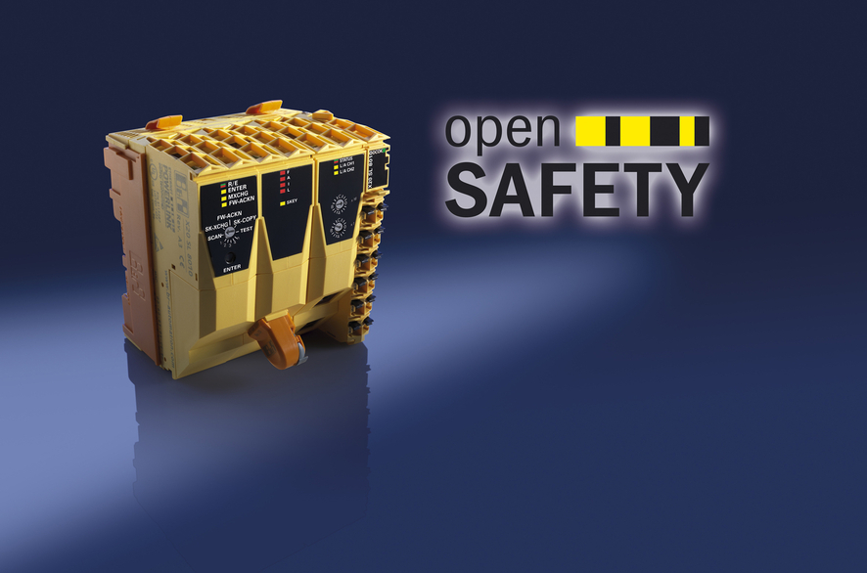
The new SafeLOGIC model from B&R allows Smart Safe Reaction technology to be used together with Profinet.

关于贝加莱
贝加莱是一家总部位于奥地利并在全球拥有分公司的创新型自动化企业。2017年7月，贝加莱成为ABB集团的机械自动化事业部。作为工业自动化领域的全球领导者，贝加莱将前沿技术与领先工程相结合，为几乎每个行业的客户提供面向机器与工厂自动化、运动控制、HMI和集成安全技术的完整解决方案。借助于OPC UA、POWERLINK、openSAFETY等工业物联网通信标准，以及强大的Automation Studio软件开发平台，贝加莱不断重新定义自动化工程的未来。受简化流程和超出客户预期的承诺驱动，贝加莱始终保持创新精神并处于工业自动化领域的前沿。
获取更多信息，请访问www.br-automation.com。

