B&R sponsors the successful Austrian Eco-Racing team
With their innovative "Fennek" vehicle, students from the Technical University of Graz presented an energy-efficient concept car that uses an absolute minimum of fuel. Comprehensive testing on the rolling friction test stand – equipped with B&R technology – made it possible to optimize running resistance and ensured continual improvement in power usage. "Fennek" made waves during the Shell Eco-marathon 2011 competition at the EuroSpeedway in Lausitz with a result of 843 km/kWh while exhibiting maximum energy efficiency.
In 2010, the Fennek achieved 1,773 km/liter (gasoline equivalent); this year the Fennek achieved 7,495 km/liter, representing an efficiency increase of over 300%. In addition to 1st place in the "Plug-in" category, the Austrian Eco-Racing team also won the CO2 evaluation.
Active project support
As a long-time partner of the TU Graz, B&R supports students in the implementation of many different types of projects. In addition to providing the absolute latest automation technology, the company's engineers are also standing by to assist with technical expertise. "We want young engineers to become familiar with our technology as early as possible," explains Thomas Dicker, the project supervisor from B&R. "When they begin their own careers later, it's possible that they will recall their experience with B&R components when developing their own solutions."

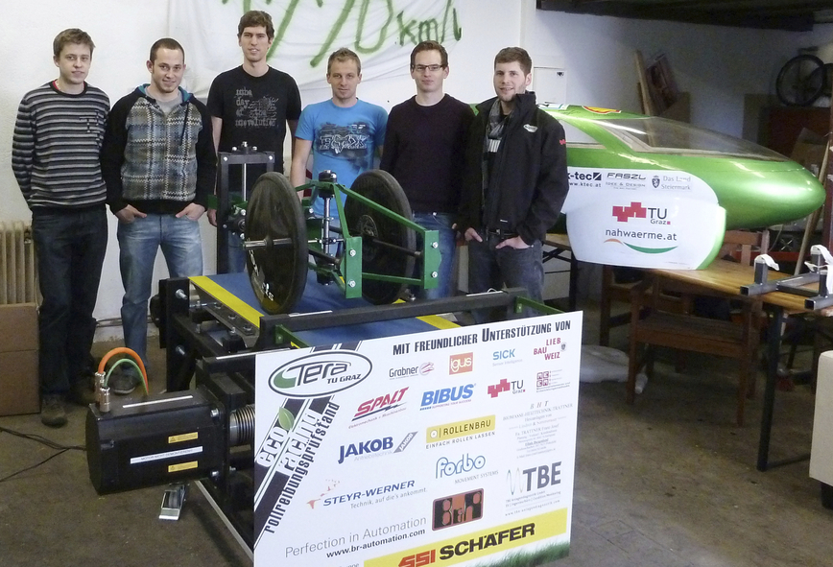
2,500 hours of development and production time were invested in the test stand. The absolute latest automation technology from B&R provided support for precision measurements.

About B&R
B&R, a division of ABB Group, is a global leader in industrial automation headquartered in Austria. B&R combines state-of-the-art technology with advanced engineering to provide customers in virtually every industry with complete solutions for machine and factory automation, motion control, HMI and integrated safety technology. With Industrial IoT communication standards including OPC UA, POWERLINK and openSAFETY as well as its Automation Studio software, B&R is constantly redefining the future of automation engineering. The innovative spirit that keeps B&R at the forefront of industrial automation is driven by a commitment to simplifying processes and exceeding customer expectations.
For more information, visit www.br-automation.com.

