B&R sponsors the successful Austrian Eco-Racing team
With their innovative "Fennek" vehicle, students from the Technical University of Graz presented an energy-efficient concept car that uses an absolute minimum of fuel. Comprehensive testing on the rolling friction test stand – equipped with B&R technology – made it possible to optimize running resistance and ensured continual improvement in power usage. "Fennek" made waves during the Shell Eco-marathon 2011 competition at the EuroSpeedway in Lausitz with a result of 843 km/kWh while exhibiting maximum energy efficiency.
In 2010, the Fennek achieved 1,773 km/liter (gasoline equivalent); this year the Fennek achieved 7,495 km/liter, representing an efficiency increase of over 300%. In addition to 1st place in the "Plug-in" category, the Austrian Eco-Racing team also won the CO2 evaluation.
Active project support
As a long-time partner of the TU Graz, B&R supports students in the implementation of many different types of projects. In addition to providing the absolute latest automation technology, the company's engineers are also standing by to assist with technical expertise. "We want young engineers to become familiar with our technology as early as possible," explains Thomas Dicker, the project supervisor from B&R. "When they begin their own careers later, it's possible that they will recall their experience with B&R components when developing their own solutions."

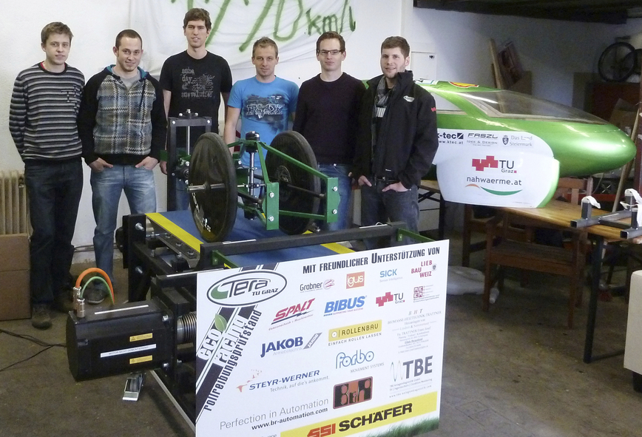
2,500 hours of development and production time were invested in the test stand. The absolute latest automation technology from B&R provided support for precision measurements.

Acerca de B&R
B&R, empresa perteneciente al Grupo ABB y con sede en Austria, es líder mundial en automatización industrial. B&R combina tecnología de vanguardia con ingeniería avanzada para proporcionar a usuarios de todos los sectores soluciones completas para la automatización de máquinas y fábricas, Motion Control, HMI y tecnología de seguridad integrada. El catálogo de productos se completa con estándares de comunicación de IoT industrial que incluyen OPC UA, POWERLINK y openSAFETY. Gracias a su única herramienta de software Automation Studio, B&R redefine constantemente el futuro de la ingeniería de automatización. El espíritu innovador que mantiene a B&R a la vanguardia de la automatización industrial está impulsado por el compromiso de simplificar los procesos y superar las expectativas de los clientes.Para más información, visite www.br-automation.com.
Para más información, visite www.br-automation.com.

