B&R sponsors the successful Austrian Eco-Racing team
With their innovative "Fennek" vehicle, students from the Technical University of Graz presented an energy-efficient concept car that uses an absolute minimum of fuel. Comprehensive testing on the rolling friction test stand – equipped with B&R technology – made it possible to optimize running resistance and ensured continual improvement in power usage. "Fennek" made waves during the Shell Eco-marathon 2011 competition at the EuroSpeedway in Lausitz with a result of 843 km/kWh while exhibiting maximum energy efficiency.
In 2010, the Fennek achieved 1,773 km/liter (gasoline equivalent); this year the Fennek achieved 7,495 km/liter, representing an efficiency increase of over 300%. In addition to 1st place in the "Plug-in" category, the Austrian Eco-Racing team also won the CO2 evaluation.
Active project support
As a long-time partner of the TU Graz, B&R supports students in the implementation of many different types of projects. In addition to providing the absolute latest automation technology, the company's engineers are also standing by to assist with technical expertise. "We want young engineers to become familiar with our technology as early as possible," explains Thomas Dicker, the project supervisor from B&R. "When they begin their own careers later, it's possible that they will recall their experience with B&R components when developing their own solutions."

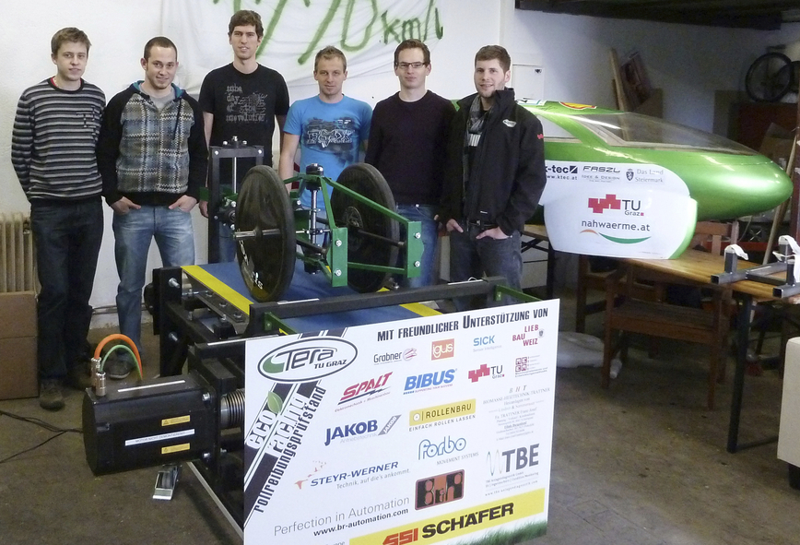
2,500 hours of development and production time were invested in the test stand. The absolute latest automation technology from B&R provided support for precision measurements.

A propos de B&R
B&R est une société d'automatismes innovante dont le siège social est basé en Autriche et qui dispose d'agences partout dans le monde. Le 6 juillet 2017, B&R est devenue une business unit du groupe ABB. Comptant parmi les leaders de l’automatisation industrielle, B&R allie technologies avancées et ingénierie de haut niveau pour fournir à ses clients, dans la quasi-totalité des industries, des solutions complètes pour l’automatisation de machines et de lignes, le contrôle de mouvements, la visualisation et la sécurité intégrée. En s’appuyant sur des standards de communication IoT Industriel comme OPC UA, POWERLINK et openSAFETY, et sur le puissant environnement de développement logiciel Automation Studio, B&R façonne l'avenir de l'ingénierie des automatismes. Forte de son leadership technologique, la société puise sa capacité d'innovation dans sa volonté de simplifier les processus et d'aller au-delà des attentes des clients.
Pour plus d'informations : www.br-automation.com

