B&R sponsors the successful Austrian Eco-Racing team
With their innovative "Fennek" vehicle, students from the Technical University of Graz presented an energy-efficient concept car that uses an absolute minimum of fuel. Comprehensive testing on the rolling friction test stand – equipped with B&R technology – made it possible to optimize running resistance and ensured continual improvement in power usage. "Fennek" made waves during the Shell Eco-marathon 2011 competition at the EuroSpeedway in Lausitz with a result of 843 km/kWh while exhibiting maximum energy efficiency.
In 2010, the Fennek achieved 1,773 km/liter (gasoline equivalent); this year the Fennek achieved 7,495 km/liter, representing an efficiency increase of over 300%. In addition to 1st place in the "Plug-in" category, the Austrian Eco-Racing team also won the CO2 evaluation.
Active project support
As a long-time partner of the TU Graz, B&R supports students in the implementation of many different types of projects. In addition to providing the absolute latest automation technology, the company's engineers are also standing by to assist with technical expertise. "We want young engineers to become familiar with our technology as early as possible," explains Thomas Dicker, the project supervisor from B&R. "When they begin their own careers later, it's possible that they will recall their experience with B&R components when developing their own solutions."

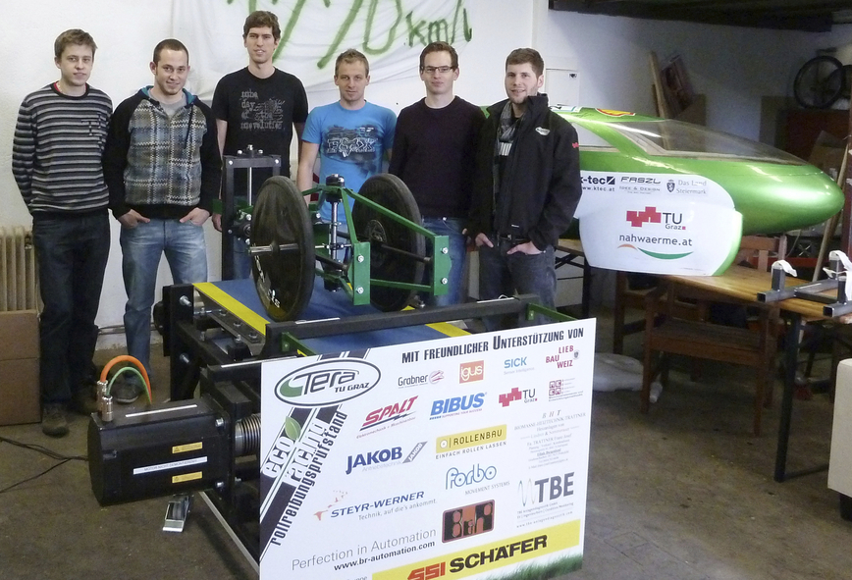
2,500 hours of development and production time were invested in the test stand. The absolute latest automation technology from B&R provided support for precision measurements.

关于贝加莱
贝加莱是一家总部位于奥地利并在全球拥有分公司的创新型自动化企业。2017年7月，贝加莱成为ABB集团的机械自动化事业部。作为工业自动化领域的全球领导者，贝加莱将前沿技术与领先工程相结合，为几乎每个行业的客户提供面向机器与工厂自动化、运动控制、HMI和集成安全技术的完整解决方案。借助于OPC UA、POWERLINK、openSAFETY等工业物联网通信标准，以及强大的Automation Studio软件开发平台，贝加莱不断重新定义自动化工程的未来。受简化流程和超出客户预期的承诺驱动，贝加莱始终保持创新精神并处于工业自动化领域的前沿。
获取更多信息，请访问www.br-automation.com。

