Open Automation Conferences 2011 in India: Cost optimization with POWERLINK and openSAFETY
The central themes of the Open Automation Technology Conferences 2011 were how companies can not only reduce costs, but simultaneously increase productivity through the use of open technologies and standards such as POWERLINK and openSAFETY for automation in the manufacturing sector. The conferences took place on 21 and 22 July in Coimbatore and Chennai in India. More than 200 visitors were invited by the Confederation of Indian Industry and the PSG College of Technology Coimbatore as well as the PSG Science and Technology Entrepreneurial Park, who organized the conference. The event was supported by the Ethernet POWERLINK Standardization Group (EPSG), B&R, and Kalycito.
Stefan Schönegger, Open Automation Business Unit Manager at B&R and General Manager of the EPSG, opened the event with an introduction to open automation, focusing on the pivotal role of automation protocols and networks. Schönegger demonstrated the particular cost advantages that POWERLINK and openSAFETY offer through their flexibility and scalability as opposed to patented systems. Bhagath Singh Karunakaran, the Managing Director of Kalycito India, explained how simply these protocols can be implemented and which components are necessary to do so. Representatives from Hyundai Motor Company and SEW were amongst those giving presentations at the conference in Chennai. Stefan Schönegger said, “The Open Automation Conferences in India were a great success. The high number of participants showed us the importance that open, patent-free technologies have in the emerging industrial nations.”

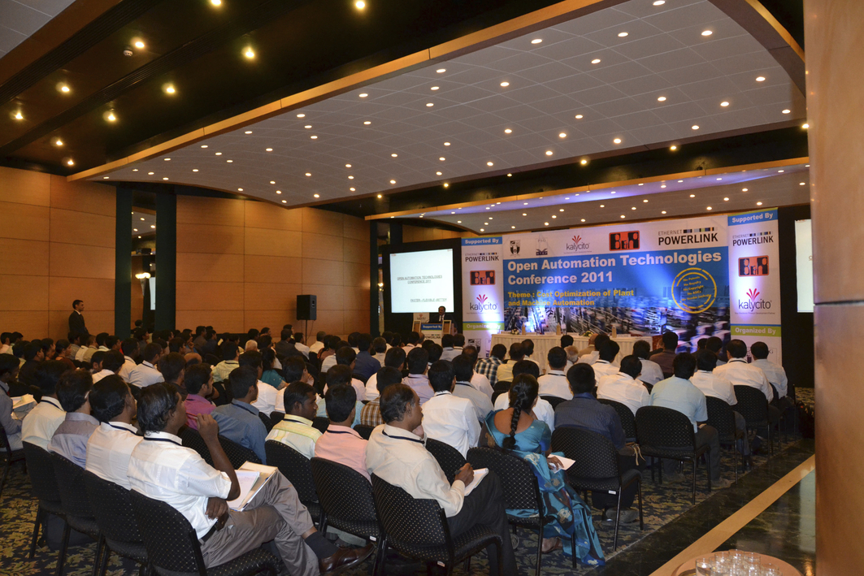
Open Automation Technology Conference in Coimbatore
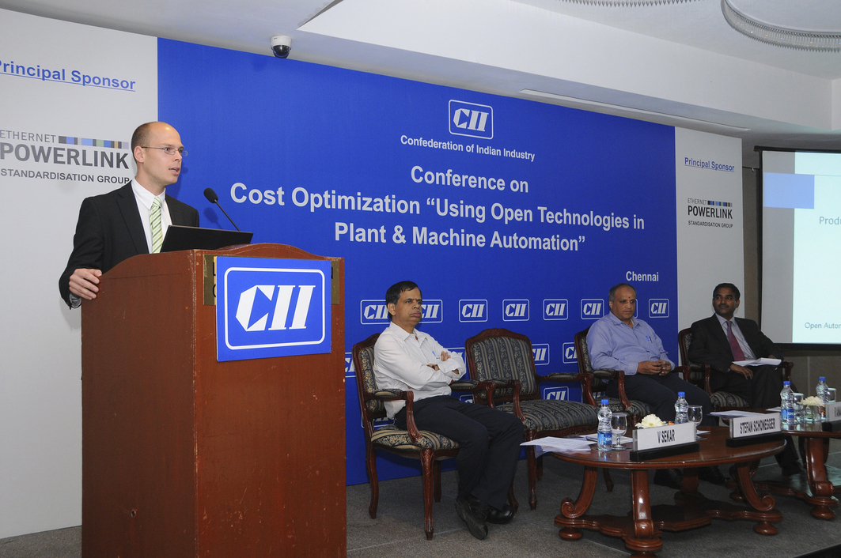
Stefan Schönegger, Open Automation Business Unit Manager at B&R, and General Manager of the EPSG, greets the participants in the Chennai conference

Acerca de B&R
B&R, empresa perteneciente al Grupo ABB y con sede en Austria, es líder mundial en automatización industrial. B&R combina tecnología de vanguardia con ingeniería avanzada para proporcionar a usuarios de todos los sectores soluciones completas para la automatización de máquinas y fábricas, Motion Control, HMI y tecnología de seguridad integrada. El catálogo de productos se completa con estándares de comunicación de IoT industrial que incluyen OPC UA, POWERLINK y openSAFETY. Gracias a su única herramienta de software Automation Studio, B&R redefine constantemente el futuro de la ingeniería de automatización. El espíritu innovador que mantiene a B&R a la vanguardia de la automatización industrial está impulsado por el compromiso de simplificar los procesos y superar las expectativas de los clientes.Para más información, visite www.br-automation.com.
Para más información, visite www.br-automation.com.

