Open Automation Conferences 2011 in India: Cost optimization with POWERLINK and openSAFETY
The central themes of the Open Automation Technology Conferences 2011 were how companies can not only reduce costs, but simultaneously increase productivity through the use of open technologies and standards such as POWERLINK and openSAFETY for automation in the manufacturing sector. The conferences took place on 21 and 22 July in Coimbatore and Chennai in India. More than 200 visitors were invited by the Confederation of Indian Industry and the PSG College of Technology Coimbatore as well as the PSG Science and Technology Entrepreneurial Park, who organized the conference. The event was supported by the Ethernet POWERLINK Standardization Group (EPSG), B&R, and Kalycito.
Stefan Schönegger, Open Automation Business Unit Manager at B&R and General Manager of the EPSG, opened the event with an introduction to open automation, focusing on the pivotal role of automation protocols and networks. Schönegger demonstrated the particular cost advantages that POWERLINK and openSAFETY offer through their flexibility and scalability as opposed to patented systems. Bhagath Singh Karunakaran, the Managing Director of Kalycito India, explained how simply these protocols can be implemented and which components are necessary to do so. Representatives from Hyundai Motor Company and SEW were amongst those giving presentations at the conference in Chennai. Stefan Schönegger said, “The Open Automation Conferences in India were a great success. The high number of participants showed us the importance that open, patent-free technologies have in the emerging industrial nations.”

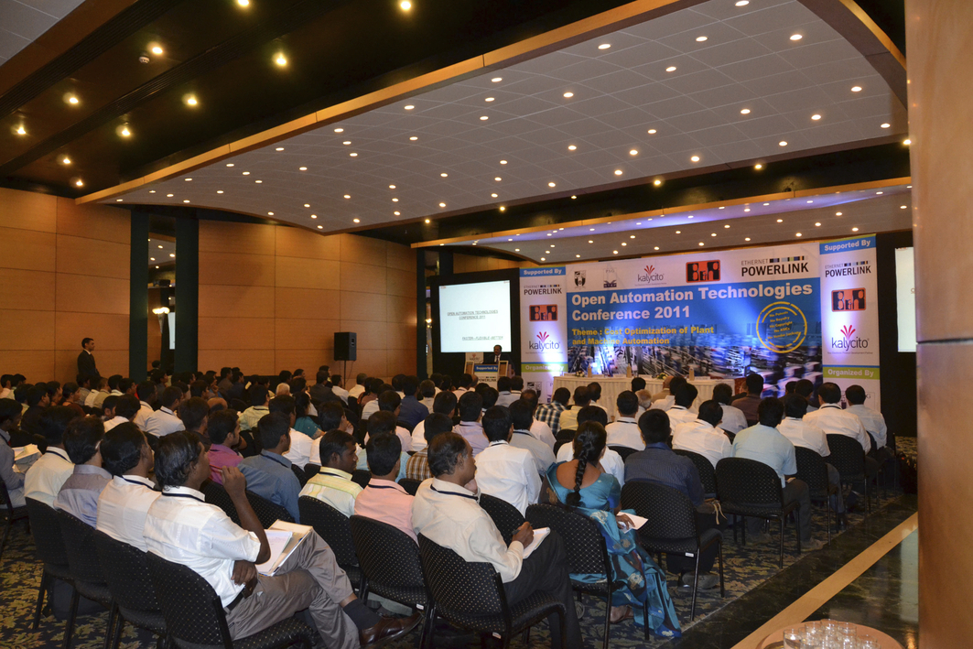
Open Automation Technology Conference in Coimbatore
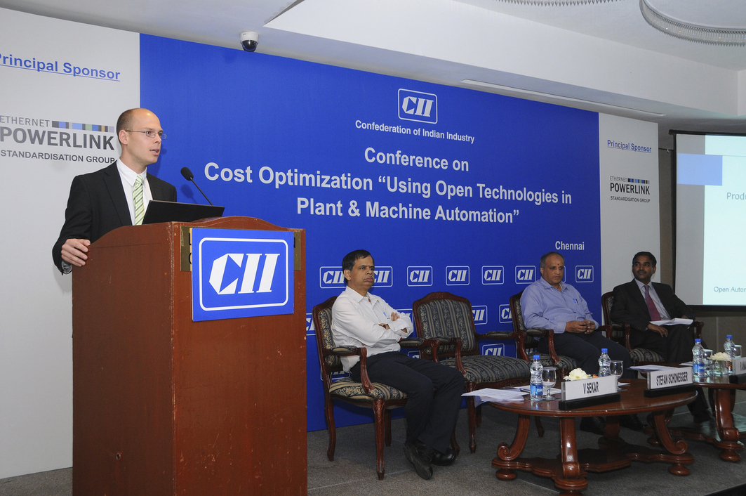
Stefan Schönegger, Open Automation Business Unit Manager at B&R, and General Manager of the EPSG, greets the participants in the Chennai conference

A propos de B&R
B&R est une société d'automatismes innovante dont le siège social est basé en Autriche et qui dispose d'agences partout dans le monde. Le 6 juillet 2017, B&R est devenue une business unit du groupe ABB. Comptant parmi les leaders de l’automatisation industrielle, B&R allie technologies avancées et ingénierie de haut niveau pour fournir à ses clients, dans la quasi-totalité des industries, des solutions complètes pour l’automatisation de machines et de lignes, le contrôle de mouvements, la visualisation et la sécurité intégrée. En s’appuyant sur des standards de communication IoT Industriel comme OPC UA, POWERLINK et openSAFETY, et sur le puissant environnement de développement logiciel Automation Studio, B&R façonne l'avenir de l'ingénierie des automatismes. Forte de son leadership technologique, la société puise sa capacité d'innovation dans sa volonté de simplifier les processus et d'aller au-delà des attentes des clients.
Pour plus d'informations : www.br-automation.com

