Open Automation Conferences 2011 in India: Cost optimization with POWERLINK and openSAFETY
The central themes of the Open Automation Technology Conferences 2011 were how companies can not only reduce costs, but simultaneously increase productivity through the use of open technologies and standards such as POWERLINK and openSAFETY for automation in the manufacturing sector. The conferences took place on 21 and 22 July in Coimbatore and Chennai in India. More than 200 visitors were invited by the Confederation of Indian Industry and the PSG College of Technology Coimbatore as well as the PSG Science and Technology Entrepreneurial Park, who organized the conference. The event was supported by the Ethernet POWERLINK Standardization Group (EPSG), B&R, and Kalycito.
Stefan Schönegger, Open Automation Business Unit Manager at B&R and General Manager of the EPSG, opened the event with an introduction to open automation, focusing on the pivotal role of automation protocols and networks. Schönegger demonstrated the particular cost advantages that POWERLINK and openSAFETY offer through their flexibility and scalability as opposed to patented systems. Bhagath Singh Karunakaran, the Managing Director of Kalycito India, explained how simply these protocols can be implemented and which components are necessary to do so. Representatives from Hyundai Motor Company and SEW were amongst those giving presentations at the conference in Chennai. Stefan Schönegger said, “The Open Automation Conferences in India were a great success. The high number of participants showed us the importance that open, patent-free technologies have in the emerging industrial nations.”

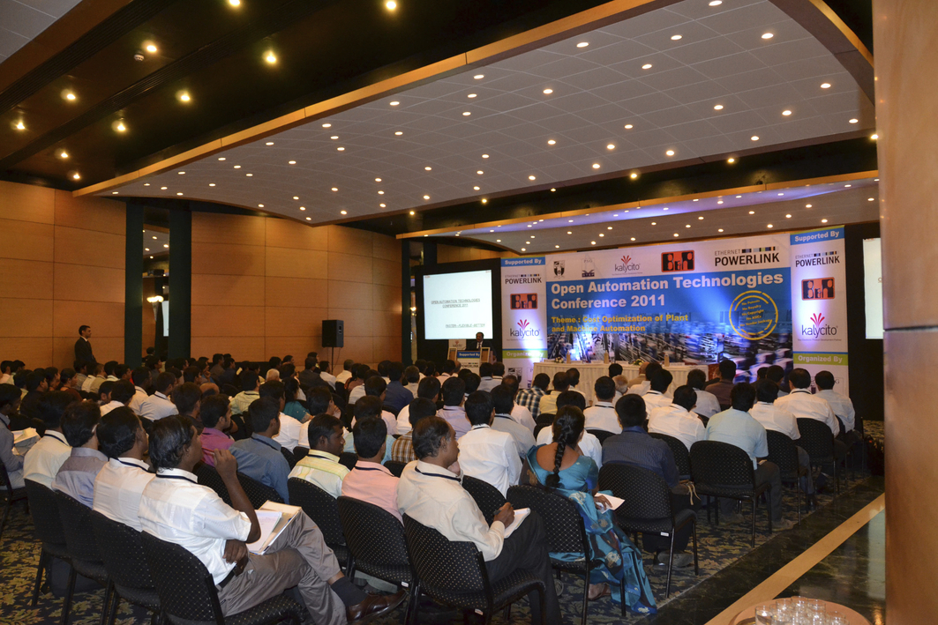
Open Automation Technology Conference in Coimbatore
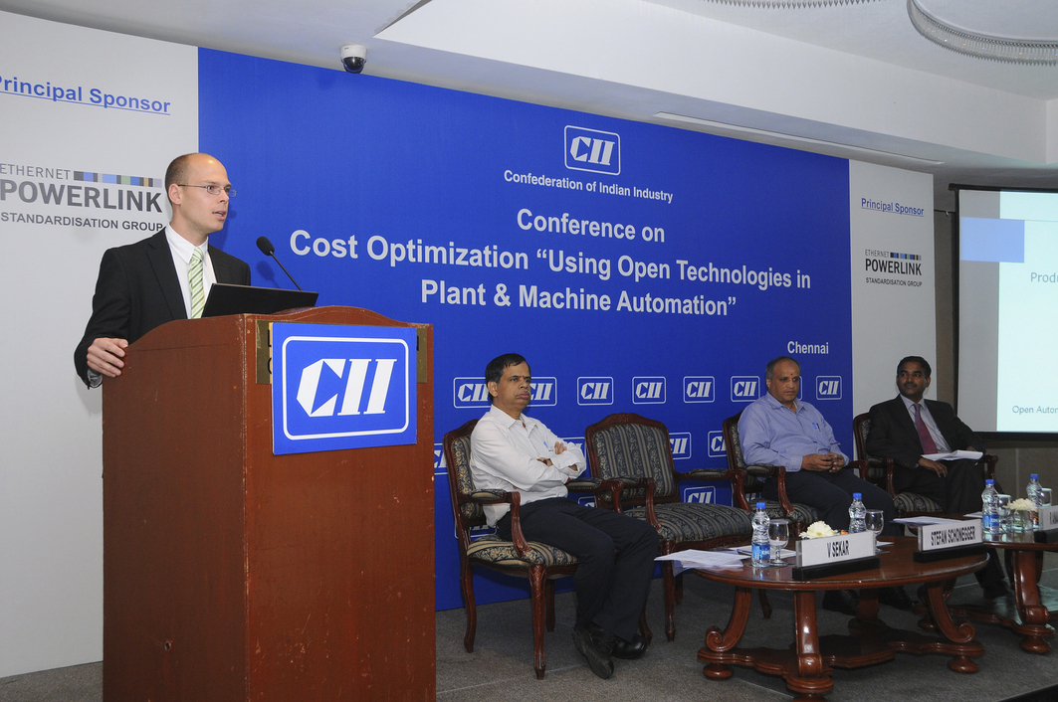
Stefan Schönegger, Open Automation Business Unit Manager at B&R, and General Manager of the EPSG, greets the participants in the Chennai conference

关于贝加莱
贝加莱是一家总部位于奥地利并在全球拥有分公司的创新型自动化企业。2017年7月，贝加莱成为ABB集团的机械自动化事业部。作为工业自动化领域的全球领导者，贝加莱将前沿技术与领先工程相结合，为几乎每个行业的客户提供面向机器与工厂自动化、运动控制、HMI和集成安全技术的完整解决方案。借助于OPC UA、POWERLINK、openSAFETY等工业物联网通信标准，以及强大的Automation Studio软件开发平台，贝加莱不断重新定义自动化工程的未来。受简化流程和超出客户预期的承诺驱动，贝加莱始终保持创新精神并处于工业自动化领域的前沿。
获取更多信息，请访问www.br-automation.com。

