Meet your goals faster with Automation Studio – A mechatronic approach combined with OOP accelerates product development
It's not uncommon for software projects to suffer delays during the development process. One reason for this is that the software itself is simply too complex and inflexible. Nevertheless, this process can be accelerated considerably by employing an object-oriented approach. By incorporating the C++ programming language, Automation Studio doesn't just provide the tools needed to do this, it also offers the flexibility to do it right.
Viewing the entire development process holistically is key when it comes to developing modern machine solutions. For this to work in practice, however, developers must have the right tools every step of the way. With its integrated simulation environment, open interfaces and seamless C++ integration, Automation Studio is the perfect platform for supporting mechatronic product development. Regardless of the task, the development team always has the right tool to master it – starting with the specification of requirements and continuing through the object-oriented analysis, design and simulation of the machine, all the way up to its commissioning. This results in a more dynamic development process across the board, reducing overall development times while simultaneously increasing the quality of the software itself.

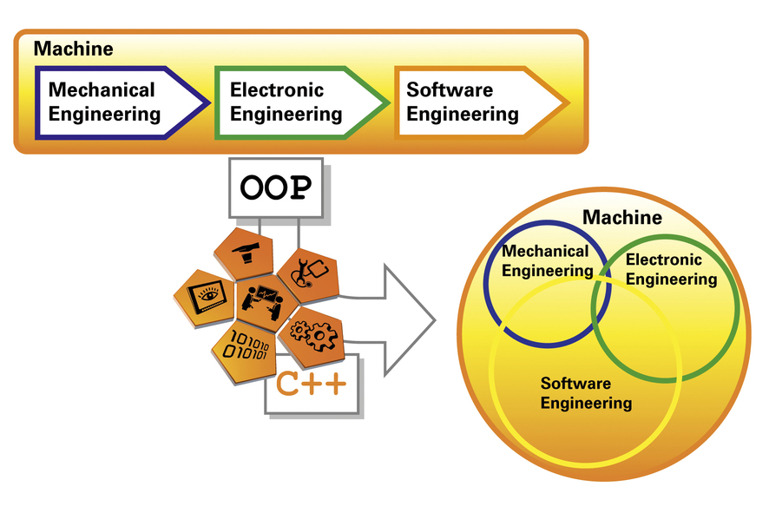
Take an object-oriented approach to development, reduce overall development times and increase the quality of your software - all with Automation Studio!

About B&R
B&R, a division of ABB Group, is a global leader in industrial automation headquartered in Austria. B&R combines state-of-the-art technology with advanced engineering to provide customers in virtually every industry with complete solutions for machine and factory automation, motion control, HMI and integrated safety technology. With Industrial IoT communication standards including OPC UA, POWERLINK and openSAFETY as well as its Automation Studio software, B&R is constantly redefining the future of automation engineering. The innovative spirit that keeps B&R at the forefront of industrial automation is driven by a commitment to simplifying processes and exceeding customer expectations.
For more information, visit www.br-automation.com.

