Meet your goals faster with Automation Studio - A mechatronic approach combined with OOP accelerates product development
It's not uncommon for software projects to suffer delays during the development process. One reason for this is that the software itself is simply too complex and inflexible. Nevertheless, this process can be accelerated considerably by employing an object-oriented approach. By incorporating the C++ programming language, Automation Studio doesn't just provide the tools needed to do this, it also offers the flexibility to do it right.
Viewing the entire development process holistically is key when it comes to developing modern machine solutions. For this to work in practice, however, developers must have the right tools every step of the way. With its integrated simulation environment, open interfaces and seamless integration of C++, Automation Studio is the perfect platform for supporting mechatronic product development. Regardless of the task, the development team always has the right tool to master it - starting with the specification of requirements and continuing through the object-oriented analysis, design and simulation of the machine, all the way up to its commissioning. This results in a more dynamic development process across the board, reducing overall development times while simultaneously increasing the quality of the software itself.

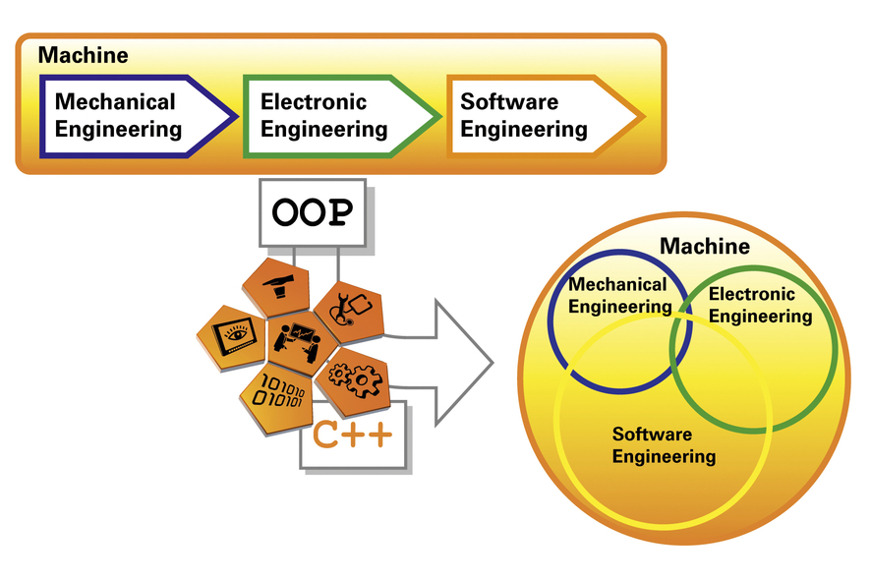
Take an object-oriented approach to development, reduce overall development times and increase the quality of your software - all with Automation Studio!

A propos de B&R
B&R est une société d'automatismes innovante dont le siège social est basé en Autriche et qui dispose d'agences partout dans le monde. Le 6 juillet 2017, B&R est devenue une business unit du groupe ABB. Comptant parmi les leaders de l’automatisation industrielle, B&R allie technologies avancées et ingénierie de haut niveau pour fournir à ses clients, dans la quasi-totalité des industries, des solutions complètes pour l’automatisation de machines et de lignes, le contrôle de mouvements, la visualisation et la sécurité intégrée. En s’appuyant sur des standards de communication IoT Industriel comme OPC UA, POWERLINK et openSAFETY, et sur le puissant environnement de développement logiciel Automation Studio, B&R façonne l'avenir de l'ingénierie des automatismes. Forte de son leadership technologique, la société puise sa capacité d'innovation dans sa volonté de simplifier les processus et d'aller au-delà des attentes des clients.
Pour plus d'informations : www.br-automation.com

