Meet your goals faster with Automation Studio – A mechatronic approach combined with OOP accelerates product development
It's not uncommon for software projects to suffer delays during the development process. One reason for this is that the software itself is simply too complex and inflexible. Nevertheless, this process can be accelerated considerably by employing an object-oriented approach. By incorporating the C++ programming language, Automation Studio doesn't just provide the tools needed to do this, it also offers the flexibility to do it right.
Viewing the entire development process holistically is key when it comes to developing modern machine solutions. For this to work in practice, however, developers must have the right tools every step of the way. With its integrated simulation environment, open interfaces and seamless C++ integration, Automation Studio is the perfect platform for supporting mechatronic product development. Regardless of the task, the development team always has the right tool to master it – starting with the specification of requirements and continuing through the object-oriented analysis, design and simulation of the machine, all the way up to its commissioning. This results in a more dynamic development process across the board, reducing overall development times while simultaneously increasing the quality of the software itself.

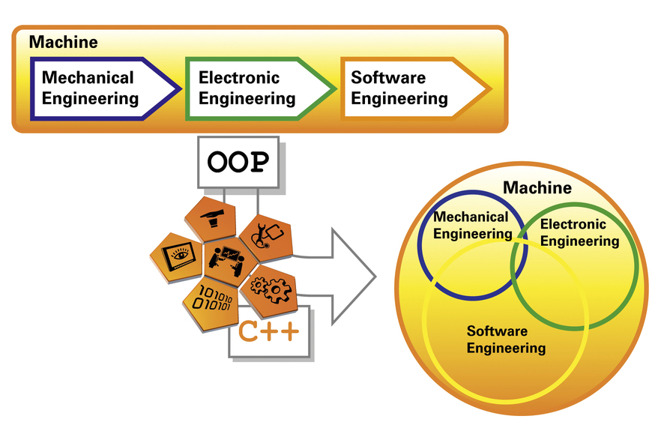
Take an object-oriented approach to development, reduce overall development times and increase the quality of your software - all with Automation Studio!

B&R Hakkında
ABB Grubunun bir bölümü olan B&R, merkezi Avusturya'da bulunan endüstriyel otomasyon alanında global bir liderdir. B&R, neredeyse her sektördeki müşterilere makine ve fabrika otomasyonu, hareket kontrolü, HMI ve entegre güvenlik teknolojisi için eksiksiz çözümler sunmak üzere en son teknolojiyi ileri mühendislikle birleştiriyor. OPC UA, POWERLINK ve openSAFETY gibi Endüstriyel IoT iletişim standartlarının yanı sıra Automation Studio yazılımıyla B&R, otomasyon mühendisliğinin geleceğini sürekli olarak yeniden tanımlıyor. B&R'ı endüstriyel otomasyonun ön saflarında tutan yenilikçi ruh, süreçleri basitleştirme ve müşteri beklentilerini aşma taahhüdünden kaynaklanmaktadır.
Daha fazla bilgi için www.br-automation.com adresini ziyaret edin.

