Meet your goals faster with Automation Studio - A mechatronic approach combined with OOP accelerates product development
It's not uncommon for software projects to suffer delays during the development process. One reason for this is that the software itself is simply too complex and inflexible. Nevertheless, this process can be accelerated considerably by employing an object-oriented approach. By incorporating the C++ programming language, Automation Studio doesn't just provide the tools needed to do this, it also offers the flexibility to do it right.
Viewing the entire development process holistically is key when it comes to developing modern machine solutions. For this to work in practice, however, developers must have the right tools every step of the way. With its integrated simulation environment, open interfaces and seamless integration of C++, Automation Studio is the perfect platform for supporting mechatronic product development. Regardless of the task, the development team always has the right tool to master it - starting with the specification of requirements and continuing through the object-oriented analysis, design and simulation of the machine, all the way up to its commissioning. This results in a more dynamic development process across the board, reducing overall development times while simultaneously increasing the quality of the software itself.

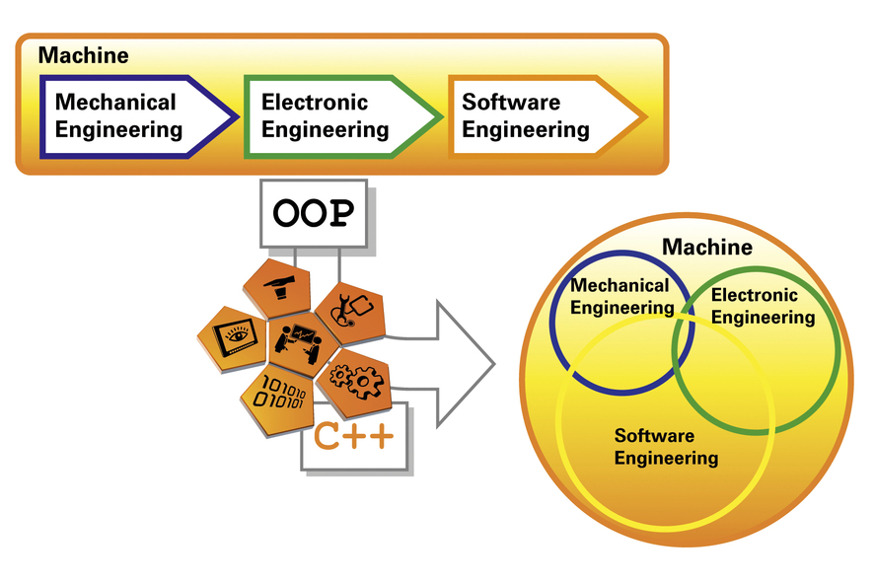
Take an object-oriented approach to development, reduce overall development times and increase the quality of your software - all with Automation Studio!

关于贝加莱
贝加莱是一家总部位于奥地利并在全球拥有分公司的创新型自动化企业。2017年7月，贝加莱成为ABB集团的机械自动化事业部。作为工业自动化领域的全球领导者，贝加莱将前沿技术与领先工程相结合，为几乎每个行业的客户提供面向机器与工厂自动化、运动控制、HMI和集成安全技术的完整解决方案。借助于OPC UA、POWERLINK、openSAFETY等工业物联网通信标准，以及强大的Automation Studio软件开发平台，贝加莱不断重新定义自动化工程的未来。受简化流程和超出客户预期的承诺驱动，贝加莱始终保持创新精神并处于工业自动化领域的前沿。
获取更多信息，请访问www.br-automation.com。

