500,000th POWERLINK system installed
At this year's Hanover Trade Fair, B&R and the EPSG officially handed over the 500,000th POWERLINK system to the international packaging machine manufacturer MediSeal, a member of the KÖRBER MEDIPAK Group. With their main focus on the pharmaceuticals and cosmetics industries, the long-term B&R customer's machine solutions require maximum safety, performance and flexibility.
The high-performance fieldbus will be used for motion control. "POWERLINK ensures optimum drive synchronization - a decisive advantage for complex motion tasks like the ones required for our highly dynamic packaging lines," states Winfried Holtey, R&D specialist for electrical engineering at MediSeal.
POWERLINK, which was introduced in 2001, is currently implemented by more than 2,500 machine manufacturers worldwide and, through the use of open source technology, is the only completely open and license-free system available on the market.
"Other industrial Ethernet network systems either provide synchronization ranging from mediocre to good, or they are specialized in cross-communication," explains Frank Winter, General Manager of B&R Germany. POWERLINK guarantees real-time data exchange between bus stations with the highest level of synchronization. And this is true regardless of the topology used. The performance of POWERLINK can't be beat, especially when synchronizing large numbers of servo axes and I/O channels.

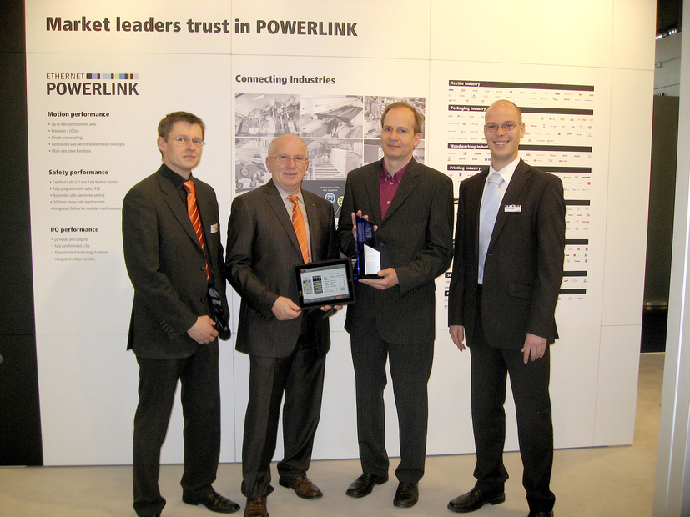
Holger Rudolf, B&R (left), Frank Winter, General Manager of B&R Germany (middle left) and EPSG Manager Stefan Schönegger (right), officially handing over the 500,000th POWERLINK system to Winfried Holtey, MediSeal.

Acerca de B&R
B&R, empresa perteneciente al Grupo ABB y con sede en Austria, es líder mundial en automatización industrial. B&R combina tecnología de vanguardia con ingeniería avanzada para proporcionar a usuarios de todos los sectores soluciones completas para la automatización de máquinas y fábricas, Motion Control, HMI y tecnología de seguridad integrada. El catálogo de productos se completa con estándares de comunicación de IoT industrial que incluyen OPC UA, POWERLINK y openSAFETY. Gracias a su única herramienta de software Automation Studio, B&R redefine constantemente el futuro de la ingeniería de automatización. El espíritu innovador que mantiene a B&R a la vanguardia de la automatización industrial está impulsado por el compromiso de simplificar los procesos y superar las expectativas de los clientes.Para más información, visite www.br-automation.com.
Para más información, visite www.br-automation.com.

