500,000th POWERLINK system installed
At this year's Hanover Trade Show, B&R and the EPSG officially handed over the 500,000th POWERLINK system to the international packaging machine manufacturer MediSeal, a member of the KÖRBER MEDIPAK Group. With their main focus on the pharmaceuticals and cosmetics industries, the long-term B&R customer's machine solutions require maximum safety, performance and flexibility.
The high-performance fieldbus will be used for motion control. "POWERLINK ensures optimum drive synchronization - a decisive advantage for complex motion tasks like the ones required for our highly dynamic packaging lines," states Winfried Holtey, R&D specialist for electrical engineering at MediSeal.
POWERLINK, which was introduced in 2001, is currently implemented by more than 2,500 machine manufacturers worldwide and, through the use of open source technology, is the only completely open and license-free system available on the market.
"Other industrial Ethernet network systems either provide synchronization ranging from mediocre to good, or they are specialized in cross-communication," explains Frank Winter, General Manager of B&R Germany. POWERLINK guarantees real-time data exchange between bus stations with the highest level of synchronization. And this is true regardless of the topology used. The performance of POWERLINK can't be beat, especially when synchronizing large numbers of servo axes and I/O channels.

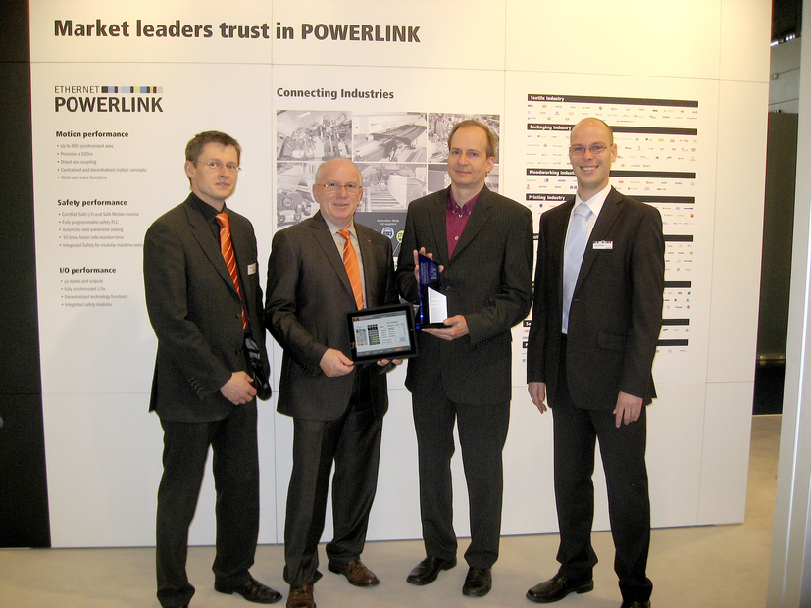
Holger Rudolf, B&R (left), Frank Winter, General Manager of B&R Germany (middle left) and EPSG Manager Stefan Schönegger (right), officially handing over the 500,000th POWERLINK system to Winfried Holtey, MediSeal.

B&R Hakkında
ABB Grubunun bir bölümü olan B&R, merkezi Avusturya'da bulunan endüstriyel otomasyon alanında global bir liderdir. B&R, neredeyse her sektördeki müşterilere makine ve fabrika otomasyonu, hareket kontrolü, HMI ve entegre güvenlik teknolojisi için eksiksiz çözümler sunmak üzere en son teknolojiyi ileri mühendislikle birleştiriyor. OPC UA, POWERLINK ve openSAFETY gibi Endüstriyel IoT iletişim standartlarının yanı sıra Automation Studio yazılımıyla B&R, otomasyon mühendisliğinin geleceğini sürekli olarak yeniden tanımlıyor. B&R'ı endüstriyel otomasyonun ön saflarında tutan yenilikçi ruh, süreçleri basitleştirme ve müşteri beklentilerini aşma taahhüdünden kaynaklanmaktadır.
Daha fazla bilgi için www.br-automation.com adresini ziyaret edin.

