500,000th POWERLINK system installed
At this year's Hanover Trade Fair, B&R and the EPSG officially handed over the 500,000th POWERLINK system to the international packaging machine manufacturer MediSeal, a member of the KÖRBER MEDIPAK Group. With their main focus on the pharmaceuticals and cosmetics industries, the long-term B&R customer's machine solutions require maximum safety, performance and flexibility.
The high-performance fieldbus will be used for motion control. "POWERLINK ensures optimum drive synchronization - a decisive advantage for complex motion tasks like the ones required for our highly dynamic packaging lines," states Winfried Holtey, R&D specialist for electrical engineering at MediSeal.
POWERLINK, which was introduced in 2001, is currently implemented by more than 2,500 machine manufacturers worldwide and, through the use of open source technology, is the only completely open and license-free system available on the market.
"Other industrial Ethernet network systems either provide synchronization ranging from mediocre to good, or they are specialized in cross-communication," explains Frank Winter, General Manager of B&R Germany. POWERLINK guarantees real-time data exchange between bus stations with the highest level of synchronization. And this is true regardless of the topology used. The performance of POWERLINK can't be beat, especially when synchronizing large numbers of servo axes and I/O channels.

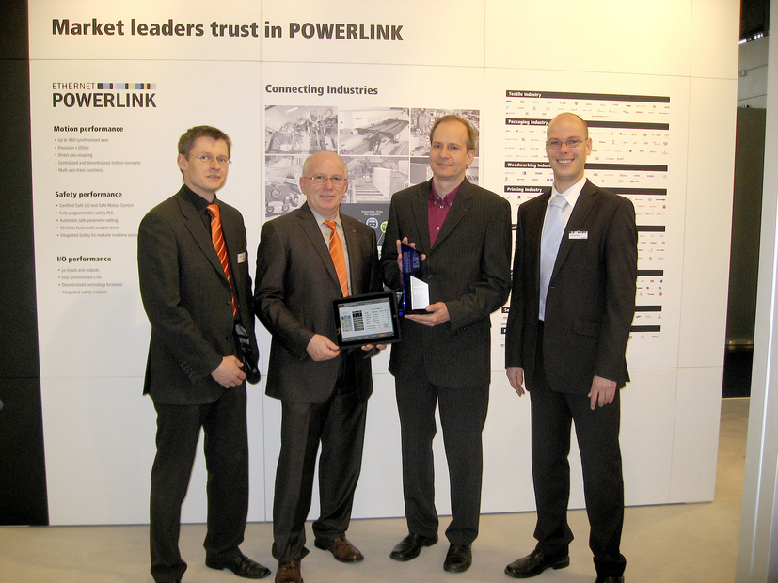
Holger Rudolf, B&R (left), Frank Winter, General Manager of B&R Germany (middle left) and EPSG Manager Stefan Schönegger (right), officially handing over the 500,000th POWERLINK system to Winfried Holtey, MediSeal.

关于贝加莱
贝加莱是一家总部位于奥地利并在全球拥有分公司的创新型自动化企业。2017年7月，贝加莱成为ABB集团的机械自动化事业部。作为工业自动化领域的全球领导者，贝加莱将前沿技术与领先工程相结合，为几乎每个行业的客户提供面向机器与工厂自动化、运动控制、HMI和集成安全技术的完整解决方案。借助于OPC UA、POWERLINK、openSAFETY等工业物联网通信标准，以及强大的Automation Studio软件开发平台，贝加莱不断重新定义自动化工程的未来。受简化流程和超出客户预期的承诺驱动，贝加莱始终保持创新精神并处于工业自动化领域的前沿。
获取更多信息，请访问www.br-automation.com。

