A record number of visitors at the B&R USER Meeting
A targeted selection of current topics for machine and system manufacturing combined with a special series of presentations focused on POWERLINK recently brought 270 participants to Salzburg. In addition to insights into B&R's latest technologies and product trends, the USER Meeting that took place on May 24th and 25th provided the ideal platform for exchanging ideas and experiences.
A targeted selection of current topics for machine and system manufacturing combined with a special series of presentations focused on POWERLINK recently brought 270 participants to Salzburg. In addition to insights into B&R's latest technologies and product trends, the USER Meeting that took place on May 24th and 25th provided the ideal platform for exchanging ideas and experiences.
In select presentations, company experts presented product innovations and the latest development projects in the area of automation. B&R Business Manager Raimund Ruf provided an overview of Power Panel developments over the last 10 years. With the latest Power Panel 500, the performance class of an industrial PC has now been achieved. "As for displays, industrial applications will follow the consumer project range," explains Mr. Ruf. Industrial displays are now following a strong trend away from 4:3 formats and toward 16:9 formats. In addition, we are also working hard on evaluating various multi-touch technologies. Our goal is to offer users a whole new level of usability in the future.
In the area of software, Dr. Hans Egermeier, Business Manager of Automation Software, explained the advantages of object-oriented programming (OOP). "The process of machine development is changing dramatically through the use of OOP," states Egermeier. As compared to procedural programming, the user has a higher initial workload with OOP, but this pays off once the machine reaches a certain level of complexity. Machine manufacturers also profit from the exceptional investment security that comes with reusable code.
Representatives from industrial fields also shared practical applications to demonstrate the exciting results achieved through their cooperation with B&R. Günter Heinendirk from the Stäubli headquarters in Germany notes the possibility for integration of Stäubli robots in POWERLINK networks. Los robots Stäubli ahora pueden ser directamente operados con controles de B&R. Esto es posible gracias al interfaz POWERLINK en los drivers uniVAL de Stäubli el cual permite transferir los programas de Generic Motion Control de los controladores de B&R a los robots. De esta manera, los ingenieros de robótica pueden usar la programación uniforme y el medio de operación proporcionado por los controles B&R.
Johannes Steinberger, general manager of Wieser Automation-Maschinenbau GmbH, reports on successful implementation of individual production lines. "The huge success of the X20 series prompted B&R to make installation more efficient and to search for new methods of fully automated series production. As part of a cooperative project, new fully automated assembly systems have been developed and put into operation within a short period of time. Besides ultrasonic welding and laser labeling, these systems now also provide a 100% inline function test."
In addition to the selected topics for machine manufacturing, the B&R USER Meeting also offered a well-coordinated series of presentations regarding process control technology and POWERLINK technology. This included a presentation of the latest APROL 3.6 developments in the area of hardware and software by Martin Reichinger, Business Manager of Process Automation, as well as a presentation about a successful oil and gas project from the company PMS. The scope of this large project for the Romanian crude oil and natural gas company, Petrom, included automation of all decentralized gas metering stations and the new gas metering center at the headquarters.
The B&R POWERLINK Day also had its premier on the first day of the conference and was a full house with over 60 participants. In a series of presentations, employees from B&R and speakers form partner companies IXXAT, port and Hilscher discussed technical questions and implementation strategies for POWERLINK as well as the bus-independent safety protocol openSAFETY.

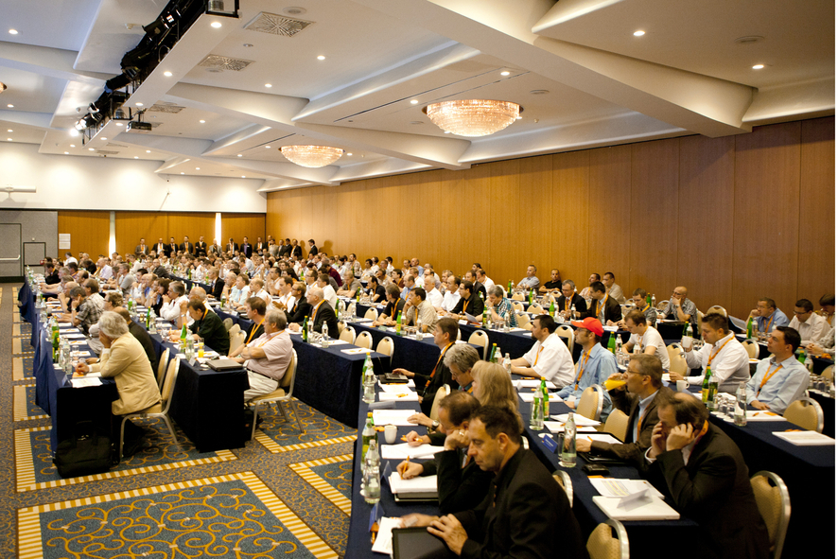
With 270 participants, there were a record number of visitors at the B&R USER Meeting.

Acerca de B&R
B&R, empresa perteneciente al Grupo ABB y con sede en Austria, es líder mundial en automatización industrial. B&R combina tecnología de vanguardia con ingeniería avanzada para proporcionar a usuarios de todos los sectores soluciones completas para la automatización de máquinas y fábricas, Motion Control, HMI y tecnología de seguridad integrada. El catálogo de productos se completa con estándares de comunicación de IoT industrial que incluyen OPC UA, POWERLINK y openSAFETY. Gracias a su única herramienta de software Automation Studio, B&R redefine constantemente el futuro de la ingeniería de automatización. El espíritu innovador que mantiene a B&R a la vanguardia de la automatización industrial está impulsado por el compromiso de simplificar los procesos y superar las expectativas de los clientes.Para más información, visite www.br-automation.com.
Para más información, visite www.br-automation.com.

