A record number of visitors at the B&R USER Meeting
A targeted selection of current topics for machine and system manufacturing combined with a special series of presentations focused on POWERLINK recently brought 270 participants to Salzburg. In addition to insights into B&R's latest technologies and product trends, the USER Meeting that took place on May 24th and 25th provided the ideal platform for exchanging ideas and experiences.
In select presentations, company experts presented product innovations and the latest development projects in the area of automation. B&R Business Manager Raimund Ruf provided an overview of Power Panel developments over the last 10 years. With the latest Power Panel 500, the performance class of an industrial PC has now been achieved. "As for displays, industrial applications will follow the consumer project range," explains Mr. Ruf. Industrial displays are now following a strong trend away from 4:3 formats and toward 16:9 formats. In addition, we are also working hard on evaluating various multi-touch technologies. Our goal is to offer users a whole new level of usability in the future.
In the area of software, Dr. Hans Egermeier, Business Manager of Automation Software, explained the advantages of object-oriented programming (OOP). "The process of machine development is changing dramatically through the use of OOP," stated Egermeier. As compared to procedural programming, the user has a higher initial workload with OOP, but this pays off once the machine reaches a certain level of complexity. Machine manufacturers also profit from the exceptional investment security that comes with reusable code.
Representatives from industrial fields also shared practical applications to demonstrate the exciting results achieved through their cooperation with B&R. Günter Heinendirk from the Stäubli headquarters in Germany notes the possibility for integration of Stäubli robots in POWERLINK networks. "This is possible thanks to a POWERLINK interface on Stäubli's uniVAL drives that allows Generic Motion Control programs from B&R controllers to be transferred to the robots. In this way, robotics engineers can use the uniform programming and operating environment provided by B&R controllers," says Mr. Heinendirk.
Johannes Steinberger, general manager of Wieser Automation-Maschinenbau GmbH, reports on successful implementation of individual production lines. "The huge success of the X20 series prompted B&R to make installation more efficient and to search for new methods of fully automated series production. As part of a cooperative project, new fully automated assembly systems have been developed and put into operation within a short period of time. Besides ultrasonic welding and laser labeling, these systems now also provide a 100% inline function test."
In addition to the selected topics for machine manufacturing, the B&R USER Meeting also offered a well-coordinated series of presentations regarding process control technology and POWERLINK technology. This included a presentation of the latest APROL 3.6 developments in the area of hardware and software by Martin Reichinger, Business Manager of Process Automation, as well as a presentation about a successful oil and gas project from the company PMS. The scope of this large project for the Romanian crude oil and natural gas company, Petrom, included automation of all decentralized gas metering stations and the new gas metering center at the headquarters.

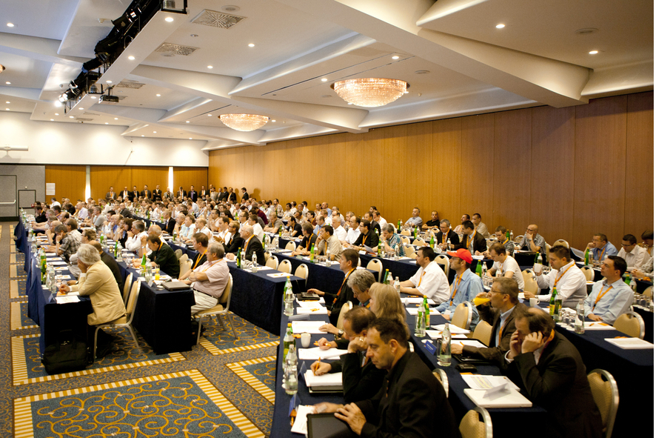
With 270 participants, there were a record number of visitors at the B&R USER Meeting.

B&R Hakkında
ABB Grubunun bir bölümü olan B&R, merkezi Avusturya'da bulunan endüstriyel otomasyon alanında global bir liderdir. B&R, neredeyse her sektördeki müşterilere makine ve fabrika otomasyonu, hareket kontrolü, HMI ve entegre güvenlik teknolojisi için eksiksiz çözümler sunmak üzere en son teknolojiyi ileri mühendislikle birleştiriyor. OPC UA, POWERLINK ve openSAFETY gibi Endüstriyel IoT iletişim standartlarının yanı sıra Automation Studio yazılımıyla B&R, otomasyon mühendisliğinin geleceğini sürekli olarak yeniden tanımlıyor. B&R'ı endüstriyel otomasyonun ön saflarında tutan yenilikçi ruh, süreçleri basitleştirme ve müşteri beklentilerini aşma taahhüdünden kaynaklanmaktadır.
Daha fazla bilgi için www.br-automation.com adresini ziyaret edin.

