A record number of visitors at the B&R USER Meeting
A targeted selection of current topics for machine and system manufacturing combined with a special series of presentations focused on POWERLINK recently brought 270 participants to Salzburg. In addition to insights into B&R's latest technologies and product trends, the USER Meeting that took place on May 24th and 25th provided the ideal platform for exchanging ideas and experiences.
A targeted selection of current topics for machine and system manufacturing combined with a special series of presentations focused on POWERLINK recently brought 270 participants to Salzburg. In addition to insights into B&R's latest technologies and product trends, the USER Meeting that took place on May 24th and 25th provided the ideal platform for exchanging ideas and experiences.
In select presentations, company experts presented product innovations and the latest development projects in the area of automation. B&R Business Manager Raimund Ruf provided an overview of Power Panel developments over the last 10 years. With the latest Power Panel 500, the performance class of an industrial PC has now been achieved. "As for displays, industrial applications will follow the consumer project range," explains Mr. Ruf. Industrial displays are now following a strong trend away from 4:3 formats and toward 16:9 formats. In addition, we are also working hard on evaluating various multi-touch technologies. Our goal is to offer users a whole new level of usability in the future.
In the area of software, Dr. Hans Egermeier, Business Manager of Automation Software, explained the advantages of object-oriented programming (OOP). "The process of machine development is changing dramatically through the use of OOP," states Egermeier. As compared to procedural programming, the user has a higher initial workload with OOP, but this pays off once the machine reaches a certain level of complexity. Machine manufacturers also profit from the exceptional investment security that comes with reusable code.
Representatives from industrial fields also shared practical applications to demonstrate the exciting results achieved through their cooperation with B&R. Günter Heinendirk from the Stäubli headquarters in Germany notes the possibility for integration of Stäubli robots in POWERLINK networks. "This is possible thanks to a POWERLINK interface on Stäubli's uniVAL drives that allows Generic Motion Control programs from B&R controllers to be transferred to the robots. In this way, robotics engineers can use the uniform programming and operating environment provided by B&R controllers," says Mr. Heinendirk.
Johannes Steinberger, general manager of Wieser Automation-Maschinenbau GmbH, reports on successful implementation of individual production lines. "The huge success of the X20 series prompted B&R to make installation more efficient and to search for new methods of fully automated series production. As part of a cooperative project, new fully automated assembly systems have been developed and put into operation within a short period of time. Besides ultrasonic welding and laser labeling, these systems now also provide a 100% inline function test."
In addition to the selected topics for machine manufacturing, the B&R USER Meeting also offered a well-coordinated series of presentations regarding process control technology and POWERLINK technology. This included a presentation of the latest APROL 3.6 developments in the area of hardware and software by Martin Reichinger, Business Manager of Process Automation, as well as a presentation about a successful oil and gas project from the company PMS. The scope of this large project for the Romanian crude oil and natural gas company, Petrom, included automation of all decentralized gas metering stations and the new gas metering center at the headquarters.
The B&R POWERLINK Day also had its premier on the first day of the conference and was a full house with over 60 participants. In a series of presentations, employees from B&R and speakers form partner companies IXXAT, port and Hilscher discussed technical questions and implementation strategies for POWERLINK as well as the bus-independent safety protocol openSAFETY.

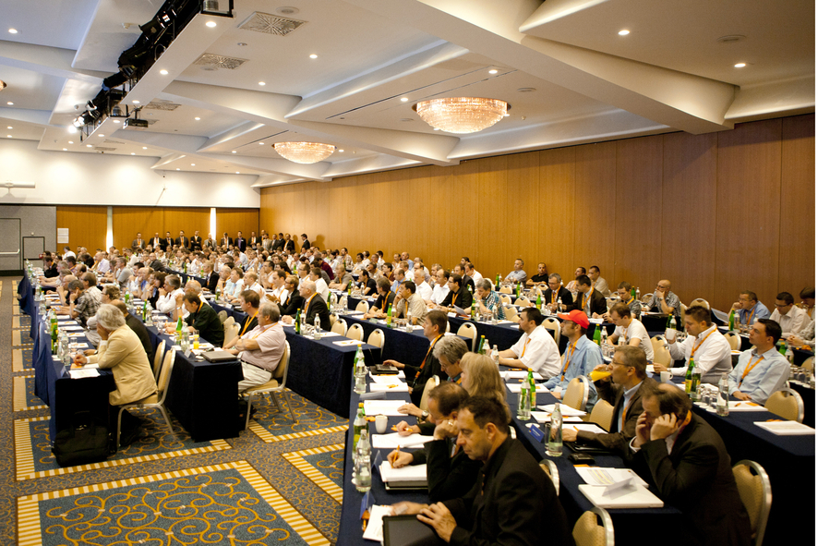
With 270 participants, there were a record number of visitors at the B&R USER Meeting.

关于贝加莱
贝加莱是一家总部位于奥地利并在全球拥有分公司的创新型自动化企业。2017年7月，贝加莱成为ABB集团的机械自动化事业部。作为工业自动化领域的全球领导者，贝加莱将前沿技术与领先工程相结合，为几乎每个行业的客户提供面向机器与工厂自动化、运动控制、HMI和集成安全技术的完整解决方案。借助于OPC UA、POWERLINK、openSAFETY等工业物联网通信标准，以及强大的Automation Studio软件开发平台，贝加莱不断重新定义自动化工程的未来。受简化流程和超出客户预期的承诺驱动，贝加莱始终保持创新精神并处于工业自动化领域的前沿。
获取更多信息，请访问www.br-automation.com。

