Frequency inverter with a POWERLINK interface
For complex machines and systems, B&R offers the ACOPOSinverter P84 with an integrated POWERLINK interface. It has a performance range of 0.37 to 500 kW. The P84 has a selection of onboard digital and analog I/O channels to control a wide range of technology functions. An integrated POWERLINK hub also greatly simplifies bus cabling.
An encoder interface can be added to the P84 for applications with strict requirements for speed or torque control. This helps fit the inverter perfectly into the B&R Motion concept and allows movements to be synchronized with the servo drives.
Thanks to the integrated B&R Automation Studio environment, no other software tools are needed. The Drive Configuration wizard assists the user when inserting the P84 into the project and handles the most important basic settings. This takes much of the guesswork out of commissioning. The System Diagnostics Manager makes it possible to perform full diagnostics or read the status of the machine - even over the Internet.

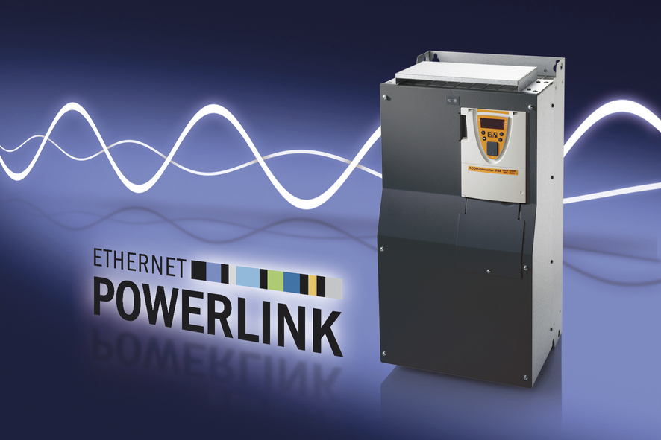
ACOPOSinverter P84 with integrated POWERLINK interface for the power range 0.37 to 500 kW.

About B&R
B&R, a division of ABB Group, is a global leader in industrial automation headquartered in Austria. B&R combines state-of-the-art technology with advanced engineering to provide customers in virtually every industry with complete solutions for machine and factory automation, motion control, HMI and integrated safety technology. With Industrial IoT communication standards including OPC UA, POWERLINK and openSAFETY as well as its Automation Studio software, B&R is constantly redefining the future of automation engineering. The innovative spirit that keeps B&R at the forefront of industrial automation is driven by a commitment to simplifying processes and exceeding customer expectations.
For more information, visit www.br-automation.com.

