Frequency inverter with a POWERLINK interface
For complex machines and systems, B&R offers the ACOPOSinverter P84 with an integrated POWERLINK interface and a performance range of 0.37 to 500 kW. The P84 has a selection of onboard digital and analog I/O channels to control a wide range of technology functions. An integrated POWERLINK hub also greatly simplifies bus cabling.
An encoder interface can be added to the P84 for applications with strict requirements for speed or torque control. This helps fit the inverter perfectly into the B&R Motion concept and allows movements to be synchronized with the servo drives.
Thanks to the integrated B&R Automation Studio environment, no other software tools are needed. The Motion Wizard assists the user when inserting the P84 into the project and handles the most important basic settings. This takes much of the guesswork out of commissioning. The System Diagnostics Manager makes it possible to perform full diagnostics or read the status of the machine - even over the Internet.

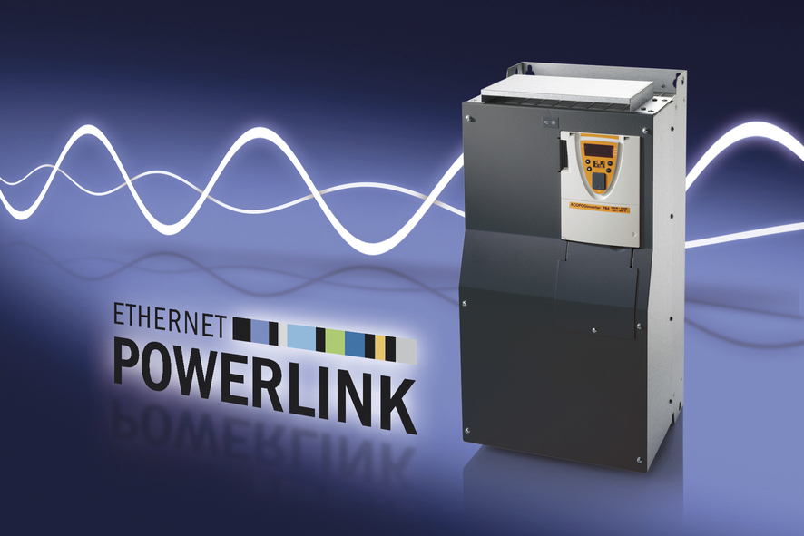
ACOPOSinverter P84 with integrated POWERLINK interface for the power range 0.37 to 500 kW.

关于贝加莱
贝加莱是一家总部位于奥地利并在全球拥有分公司的创新型自动化企业。2017年7月，贝加莱成为ABB集团的机械自动化事业部。作为工业自动化领域的全球领导者，贝加莱将前沿技术与领先工程相结合，为几乎每个行业的客户提供面向机器与工厂自动化、运动控制、HMI和集成安全技术的完整解决方案。借助于OPC UA、POWERLINK、openSAFETY等工业物联网通信标准，以及强大的Automation Studio软件开发平台，贝加莱不断重新定义自动化工程的未来。受简化流程和超出客户预期的承诺驱动，贝加莱始终保持创新精神并处于工业自动化领域的前沿。
获取更多信息，请访问www.br-automation.com。

