Efficient development through physical modelling
B&R and Maplesoft announced a partnership that will bring together products from both companies to save time, effort and cost for hardware-in-the-loop simulations.
Being able to design an adequate machine or system model plays an important role in simulation-based development. At the same time, mapping out all the dynamic characteristics of a machine can take a lot of time. "Tools for physical modeling such as MapleSim™ from Maplesoft™ provide optimal support and reduce the amount of time and work considerably," said Philipp Wallner, Global Technology Manager at B&R.
The open architecture of Automation Studio - B&R's programming and development software - ensures that physical models designed in MapleSim™ can be transferred to B&R controller hardware in just a few easy steps. The result is a hardware-in-the-loop simulation that emulates the machine's behavior in real time, in a completely safe testing environment.
“Using MapleSim, Automation Studio users can very quickly develop high-fidelity models of the control plant, analyze the dynamics, and then generate highly optimized real-time code for the plant,” said Dr. Laurent Bernardin, Vice President, Research and Development, Maplesoft. “By adding an easy-to-use and cost-effective physical modeling phase to the automation workflow, engineers will be able to increase virtual testing prior to hardware commitments. A definite way to reduce costly design errors.”
The close cooperation between the two companies ensures optimal integration in Automation Studio, a clear and comprehensive workflow, and long-term support for the user.

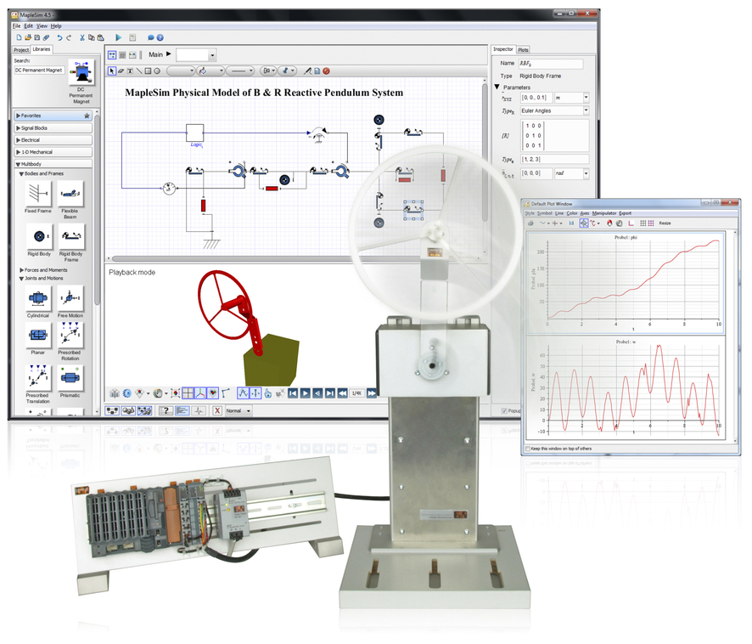
Models created in MapleSim™ can be transferred to the B&R platform with minimal effort.

A propos de B&R
B&R est une société d'automatismes innovante dont le siège social est basé en Autriche et qui dispose d'agences partout dans le monde. Le 6 juillet 2017, B&R est devenue une business unit du groupe ABB. Comptant parmi les leaders de l’automatisation industrielle, B&R allie technologies avancées et ingénierie de haut niveau pour fournir à ses clients, dans la quasi-totalité des industries, des solutions complètes pour l’automatisation de machines et de lignes, le contrôle de mouvements, la visualisation et la sécurité intégrée. En s’appuyant sur des standards de communication IoT Industriel comme OPC UA, POWERLINK et openSAFETY, et sur le puissant environnement de développement logiciel Automation Studio, B&R façonne l'avenir de l'ingénierie des automatismes. Forte de son leadership technologique, la société puise sa capacité d'innovation dans sa volonté de simplifier les processus et d'aller au-delà des attentes des clients.
Pour plus d'informations : www.br-automation.com

