Increased efficiency during development through physical modeling
B&R and Maplesoft announced a partnership that will bring together products from both companies to save time, effort and cost for hardware-in-the-loop simulations.
Being able to design an adequate machine or system model plays an important role in simulation-based development. At the same time, mapping out all of the dynamic characteristics of a machine can take up a lot of time. "Tools for physical modeling – for example, MapleSim™ from Maplesoft™ –provide optimal support and reduce the amount of time and work considerably," said Philipp Wallner, Global Technology Manager at B&R.
The open architecture of Automation Studio ensures that physical models designed in MapleSim™ can be transferred to B&R controller hardware in just a few easy steps. The result is a hardware-in-the-loop simulation that emulates the machine's behavior in real time – in a completely safe testing environment.
"Using MapleSim, Automation Studio users can very quickly develop high-fidelity models of the control plant, analyze the dynamics, and then generate highly optimized real-time code for the plant," said Dr. Laurent Bernardin, vice president of R&D at Maplesoft. "By adding an easy-to-use and cost-effective physical modeling phase to the automation workflow, engineers will be able to increase virtual testing prior to hardware commitments. A definite way to reduce costly design errors."
The close cooperation between B&R and Maplesoft ensures optimal integration in Automation Studio, a clear and comprehensive workflow and enduring support for the user.

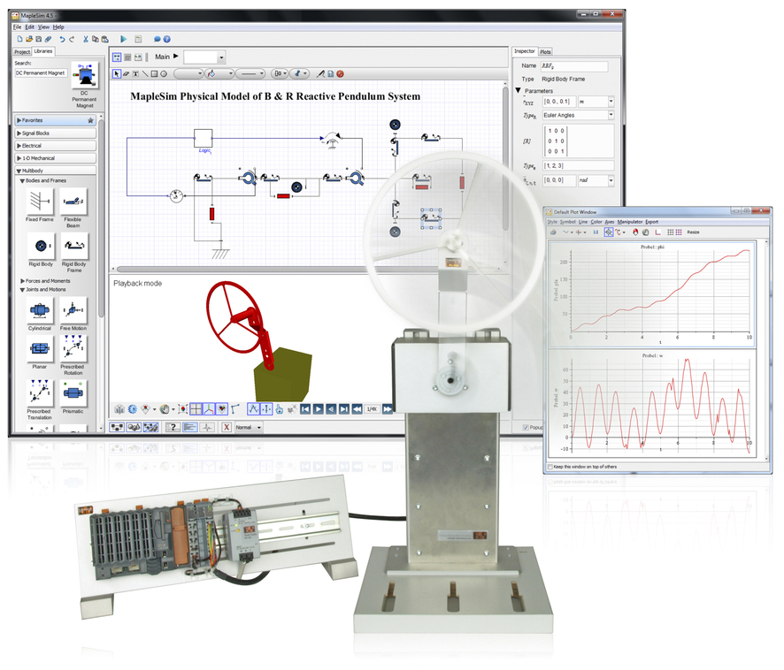
Models created in MapleSim™ can be transferred to the B&R platform with minimal effort.

B&R Hakkında
ABB Grubunun bir bölümü olan B&R, merkezi Avusturya'da bulunan endüstriyel otomasyon alanında global bir liderdir. B&R, neredeyse her sektördeki müşterilere makine ve fabrika otomasyonu, hareket kontrolü, HMI ve entegre güvenlik teknolojisi için eksiksiz çözümler sunmak üzere en son teknolojiyi ileri mühendislikle birleştiriyor. OPC UA, POWERLINK ve openSAFETY gibi Endüstriyel IoT iletişim standartlarının yanı sıra Automation Studio yazılımıyla B&R, otomasyon mühendisliğinin geleceğini sürekli olarak yeniden tanımlıyor. B&R'ı endüstriyel otomasyonun ön saflarında tutan yenilikçi ruh, süreçleri basitleştirme ve müşteri beklentilerini aşma taahhüdünden kaynaklanmaktadır.
Daha fazla bilgi için www.br-automation.com adresini ziyaret edin.

