Efficient development through physical modelling
B&R and Maplesoft announced a partnership that will bring together products from both companies to save time, effort and cost for hardware-in-the-loop simulations.
Being able to design an adequate machine or system model plays an important role in simulation-based development. At the same time, mapping out all the dynamic characteristics of a machine can take a lot of time. "Tools for physical modeling such as MapleSim™ from Maplesoft™ provide optimal support and reduce the amount of time and work considerably," said Philipp Wallner, Global Technology Manager at B&R.
The open architecture of Automation Studio - B&R's programming and development software - ensures that physical models designed in MapleSim™ can be transferred to B&R controller hardware in just a few easy steps. The result is a hardware-in-the-loop simulation that emulates the machine's behavior in real time, in a completely safe testing environment.
“Using MapleSim, Automation Studio users can very quickly develop high-fidelity models of the control plant, analyze the dynamics, and then generate highly optimized real-time code for the plant,” said Dr. Laurent Bernardin, Vice President, Research and Development, Maplesoft. “By adding an easy-to-use and cost-effective physical modeling phase to the automation workflow, engineers will be able to increase virtual testing prior to hardware commitments. A definite way to reduce costly design errors.”
The close cooperation between the two companies ensures optimal integration in Automation Studio, a clear and comprehensive workflow, and long-term support for the user.

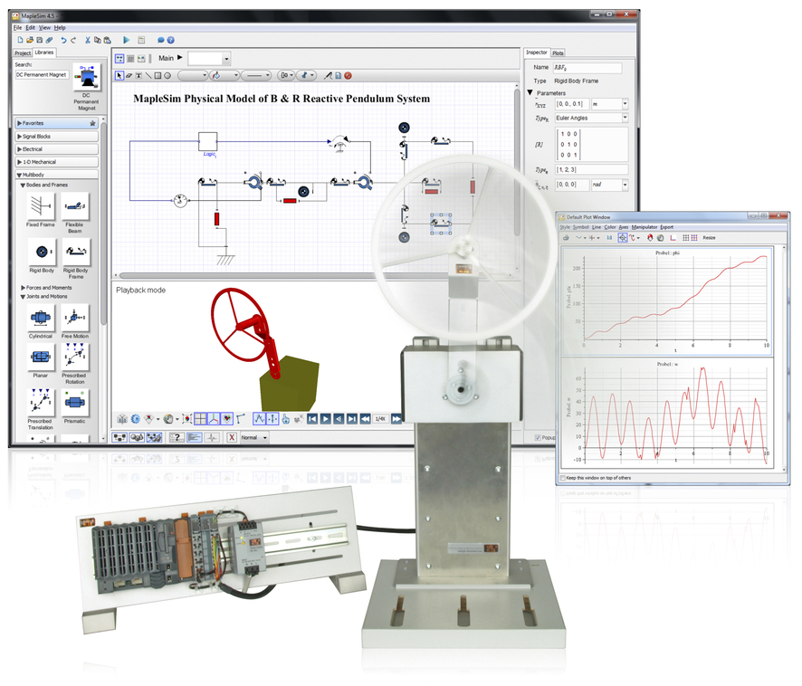
Models created in MapleSim™ can be transferred to the B&R platform with minimal effort.

关于贝加莱
贝加莱是一家总部位于奥地利并在全球拥有分公司的创新型自动化企业。2017年7月，贝加莱成为ABB集团的机械自动化事业部。作为工业自动化领域的全球领导者，贝加莱将前沿技术与领先工程相结合，为几乎每个行业的客户提供面向机器与工厂自动化、运动控制、HMI和集成安全技术的完整解决方案。借助于OPC UA、POWERLINK、openSAFETY等工业物联网通信标准，以及强大的Automation Studio软件开发平台，贝加莱不断重新定义自动化工程的未来。受简化流程和超出客户预期的承诺驱动，贝加莱始终保持创新精神并处于工业自动化领域的前沿。
获取更多信息，请访问www.br-automation.com。

