Hardware-in-the-loop for the automotive industry
Hardware-in-the-loop – or HIL – has been a proven element of model-based development for many years. Machine models developed in simulation tools like Simulink® or MapleSim™ are transferred via automatic code generation to a real-time environment where they emulate the behavior of the system. The result is a secure development environment for critical testing of new functions.
HIL on industrial PCs from B&R
Standard HIL solutions are based on expensive and unwieldy laboratory hardware, but industry-proven PCs from B&R are the perfect platform for this purpose. B&R systems can communicate using many standard fieldbus interfaces and are well-suited for continuous operation in harsh industrial environments. Using "Automation Studio Target for Simulink", system models implemented in the simulation environment are transferred to the real-time platform at the push of a button. A wide range of modern control and drive products makes it possible to model an entire system. "Developers of test stations or test environments in the automobile and aerospace industries in particular are able to profit directly from the advantages of B&R systems," states Elmar Zimmerling, global account manager for the automotive industry at B&R.

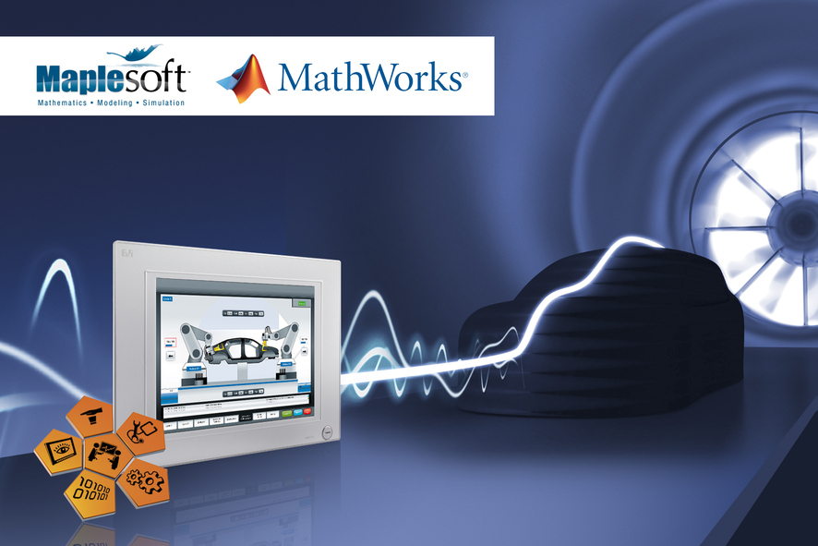
Hardware-in-the-loop on a B&R control platform is a secure development environment for the automotive industry.

About B&R
B&R, a division of ABB Group, is a global leader in industrial automation headquartered in Austria. B&R combines state-of-the-art technology with advanced engineering to provide customers in virtually every industry with complete solutions for machine and factory automation, motion control, HMI and integrated safety technology. With Industrial IoT communication standards including OPC UA, POWERLINK and openSAFETY as well as its Automation Studio software, B&R is constantly redefining the future of automation engineering. The innovative spirit that keeps B&R at the forefront of industrial automation is driven by a commitment to simplifying processes and exceeding customer expectations.
For more information, visit www.br-automation.com.

