Hardware-in-the-loop for the automotive industry
Hardware-in-the-loop - or HIL - has been a proven element of model-based development for many years. Machine models developed in simulation tools like Simulink® or MapleSim™ are transferred via automatic code generation to a real-time environment where they emulate the behavior of the system. The result is a secure development environment for critical testing of new functions.
HIL on industrial PCs from B&R
Standard HIL solutions are based on expensive and unwieldy laboratory hardware, but industry-proven PCs from B&R are the perfect platform for this purpose. B&R systems can communicate using many standard fieldbus interfaces and are well-suited for continuous operation in harsh industrial environments. Using "Automation Studio Target for Simulink", system models implemented in the simulation environment are transferred to the real-time platform at the push of a button. A wide range of modern control and drive products makes it possible to model an entire system. "Developers of test stations or test environments in the automobile and aerospace industries in particular are able to profit directly from the advantages of B&R systems," states Elmar Zimmerling, global account manager for the automotive industry at B&R.

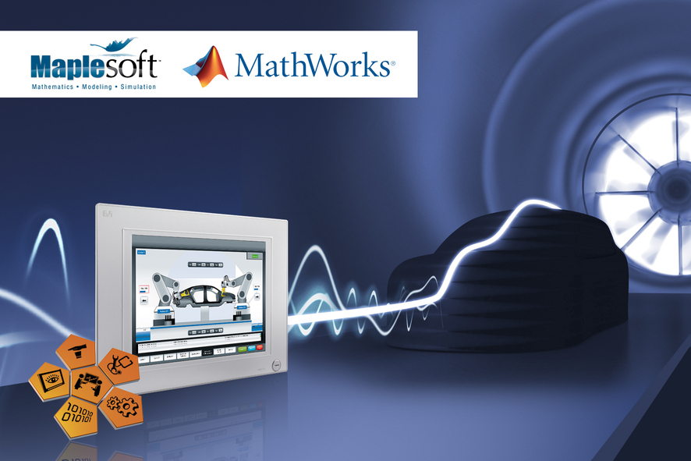
Hardware-in-the-loop on a B&R control platform is a secure development environment for the automotive industry.

关于贝加莱
贝加莱是一家总部位于奥地利并在全球拥有分公司的创新型自动化企业。2017年7月，贝加莱成为ABB集团的机械自动化事业部。作为工业自动化领域的全球领导者，贝加莱将前沿技术与领先工程相结合，为几乎每个行业的客户提供面向机器与工厂自动化、运动控制、HMI和集成安全技术的完整解决方案。借助于OPC UA、POWERLINK、openSAFETY等工业物联网通信标准，以及强大的Automation Studio软件开发平台，贝加莱不断重新定义自动化工程的未来。受简化流程和超出客户预期的承诺驱动，贝加莱始终保持创新精神并处于工业自动化领域的前沿。
获取更多信息，请访问www.br-automation.com。

