La technologie d'asservissement de B&R offre un grand potentiel d'économies d'énergie
En raison du souci accru de préservation de l'environnement et des nouvelles opportunités liées aux filières environnementales, de plus en plus de constructeurs de machines optent pour des technologies de motion control innovantes. If motors and drive components are generally working with a level of efficiency near 100% when operating at the rated load, it makes sense to have a look at the secondary components around the actual drive system.
"The sum of many individual measures can turn out to be very significant. When using the right components, large amounts of energy can be saved in the area around the drive system with relatively little effort," states Alois Holzleitner, Business Manager for Motion Control at B&R.
Optimal drive sizing reduces energy consumption
B&R ensures that drives can be sized in a targeted manner using the SERVOsoft tool from ControlEng. The masses to be moved and the drives needed to do it can be perfectly matched, which reduces energy consumption to a minimum.
For complex machines where movements are executed consecutively, kinetic energy is often released in the braking resistors in the form of heat. By connecting ACOPOSmulti servo drives via the DC bus, up to 30% of the energy used for movements can be saved. Brake energy is stored in capacitors and made available at a later time for acceleration. The user profits not only from efficient use of energy, but also from a cooler control cabinet because the heat from the resistors is greatly reduced.
Active energy regeneration saves up to 80%
In cases where braking and acceleration within an axis group do not often take place simultaneously, a further increase in energy efficiency can be achieved through active energy regeneration on the power mains. While all of the brake energy is put to use, unavoidable friction remains as the sole source of loss. With the use of modern ACOPOSmulti drive systems, it is possible to cost-effectively regenerate up to 80% of the energy previously lost as heat in the resistors.
Energy-saving measures are supported by B&R through cold-plate control cabinet installation. This provides the option of using the energy from heat loss that occurs in the servo drives themselves where it is needed via fluid circulation and a heat exchanger. "A big advantage of cold-plate technology is that a separate cooling device is no longer needed for the control cabinet. This provides savings of up to 23%," states Alois Holzleitner.
A further energy-saving effect of using the ACOPOSmulti family of products is correcting the total power factor (TPF) to 1.0. While conventional inverters with a small TPF exhibit considerably higher effective power consumption, which leads to unnecessary loss in the supply lines and transformers, the active power supply of the ACOPOSmulti ensures that the energy is used efficiently. "This saves up to 50% of the infrastructure costs by reducing the size of wires, feed components and fuses," explains the B&R business manager.

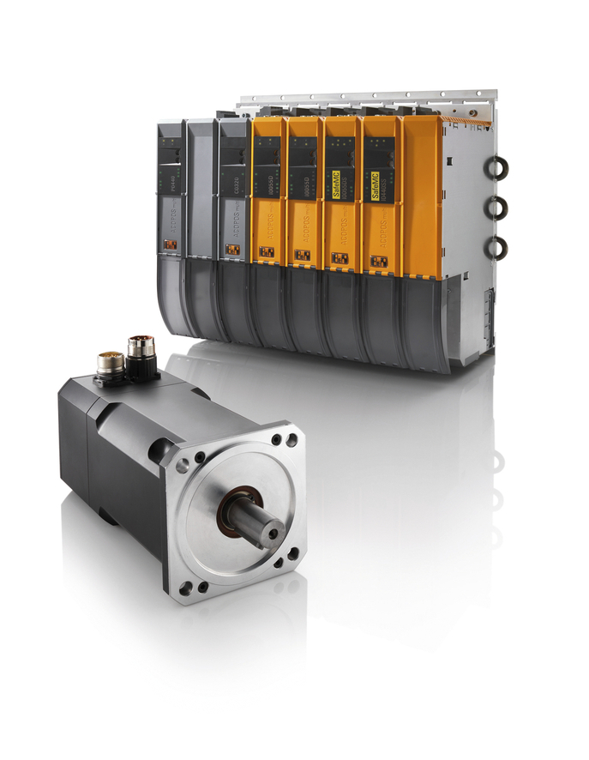
With cold-plate control cabinet installation, heat from drives can be directly dissipated and used, for example, as heat for the process. This saves the cost of control cabinet cooling devices as well as the energy they consume.

A propos de B&R
B&R est une société d'automatismes innovante dont le siège social est basé en Autriche et qui dispose d'agences partout dans le monde. Le 6 juillet 2017, B&R est devenue une business unit du groupe ABB. Comptant parmi les leaders de l’automatisation industrielle, B&R allie technologies avancées et ingénierie de haut niveau pour fournir à ses clients, dans la quasi-totalité des industries, des solutions complètes pour l’automatisation de machines et de lignes, le contrôle de mouvements, la visualisation et la sécurité intégrée. En s’appuyant sur des standards de communication IoT Industriel comme OPC UA, POWERLINK et openSAFETY, et sur le puissant environnement de développement logiciel Automation Studio, B&R façonne l'avenir de l'ingénierie des automatismes. Forte de son leadership technologique, la société puise sa capacité d'innovation dans sa volonté de simplifier les processus et d'aller au-delà des attentes des clients.
Pour plus d'informations : www.br-automation.com

