High potential for energy savings with B&R servo technology
Because of increased environmental awareness and to take advantage of new business opportunities, more and more machine and system manufacturers are choosing to implement innovative motion control technologies. If motors and drive components are generally working with a level of efficiency near 100% when operating at the rated load, it makes sense to have a look at the secondary components around the actual drive system.
"The sum of many individual measures can turn out to be very significant. When using the right components, large amounts of energy can be saved in the area around the drive system with relatively little effort," states Alois Holzleitner, Business Manager for Motion Control at B&R.
Optimal drive sizing reduces energy consumption
B&R ensures that drives can be sized in a targeted manner using the SERVOsoft tool from ControlEng. The masses to be moved and the drives needed to do it can be perfectly matched, which reduces energy consumption to a minimum.
For complex machines where movements are executed consecutively, kinetic energy is often released in the braking resistors in the form of heat. By connecting ACOPOSmulti servo drives via the DC bus, up to 30% of the energy used for movements can be saved. Brake energy is stored in capacitors and made available at a later time for acceleration. The user profits not only from efficient use of energy, but also from a cooler control cabinet because the heat from the resistors is greatly reduced.
Active energy regeneration saves up to 80%
In cases where braking and acceleration within an axis group do not often take place simultaneously, a further increase in energy efficiency can be achieved through active energy regeneration on the power mains. While all of the brake energy is put to use, unavoidable friction remains as the sole source of loss. With the use of modern ACOPOSmulti drive systems, it is possible to cost-effectively regenerate up to 80% of the energy previously lost as heat in the resistors.
Energy-saving measures are supported by B&R through cold-plate control cabinet installation. This provides the option of using the energy from heat loss that occurs in the servo drives themselves where it is needed via fluid circulation and a heat exchanger. "A big advantage of cold-plate technology is that a separate cooling device is no longer needed for the control cabinet. This provides savings of up to 23%," states Alois Holzleitner.
A further energy-saving effect of using the ACOPOSmulti family of products is correcting the total power factor (TPF) to 1.0. While conventional inverters with a small TPF exhibit considerably higher effective power consumption, which leads to unnecessary loss in the supply lines and transformers, the active power supply of the ACOPOSmulti ensures that the energy is used efficiently. "This saves up to 50% of the infrastructure costs by reducing the size of wires, feed components and fuses," explains the B&R business manager.

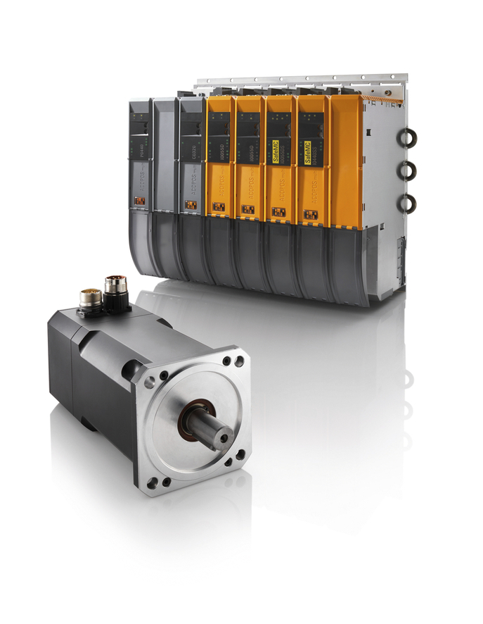
With cold-plate control cabinet installation, heat from drives can be directly dissipated and used, for example, as heat for the process. This saves the cost of control cabinet cooling devices as well as the energy they consume.

关于贝加莱
贝加莱是一家总部位于奥地利并在全球拥有分公司的创新型自动化企业。2017年7月，贝加莱成为ABB集团的机械自动化事业部。作为工业自动化领域的全球领导者，贝加莱将前沿技术与领先工程相结合，为几乎每个行业的客户提供面向机器与工厂自动化、运动控制、HMI和集成安全技术的完整解决方案。借助于OPC UA、POWERLINK、openSAFETY等工业物联网通信标准，以及强大的Automation Studio软件开发平台，贝加莱不断重新定义自动化工程的未来。受简化流程和超出客户预期的承诺驱动，贝加莱始终保持创新精神并处于工业自动化领域的前沿。
获取更多信息，请访问www.br-automation.com。

