Modular drive solutions for the highest level of performance
Drive solutions that are tailored exactly to the application are essential to keeping machines and systems competitive. It's clear that inverters also need to leave the control cabinet behind and migrate to where the action is taking place. This allows configurable modules to become easily connected mechatronic devices. It also makes it possible to reduce delivery times, free up valuable floor space and simplify commissioning.
That's why directly integrating inverters in the immediate environment of the actuator – without the need for additional accompanying measures – is the perfect solution. B&R developed the ACOPOSmulti65 inverter for applications where the drive is mounted directly on the machine.
ACOPOSmulti65 inverters are designed with IP65 protection, which makes it possible to mount them directly on the machine. The control cabinet then only has to contain the power supply modules and other necessary electromechanical components. The result is a much easier implementation of modular machine architectures.
Another advantage has to do with the hybrid cabling between the inverters themselves. Simply connecting ACOPOSmulti65 drive modules together in a line – the "daisy chain" wiring scheme – results in an uncomplicated and flexible machine architecture where energy is passed from one drive module to the next.
In addition to the proven wired safety functions STO (Safe Torque Off) and SS1 (Safe Operational Stop 1 time-monitored), network-based ACOPOSmulti65 variants, which are based on openSAFETY, will also be available in the future as an option. This will allow users to access the following functions that have already been certified for ACOPOSmulti: STO, SBC, SOS, SS1, SS2, SLS, SMS, SLI, SDI, and SLP.

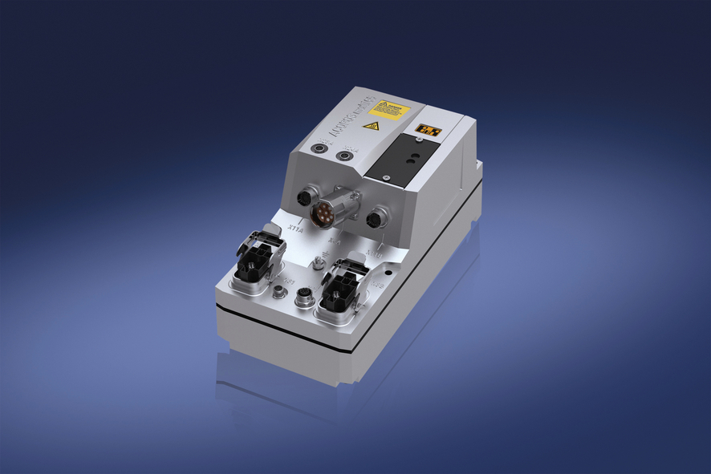
The ACOPOSmulti65 inverter for applications where the drive is mounted directly on the machine makes flexible machine configurations possible.

B&R Hakkında
ABB Grubunun bir bölümü olan B&R, merkezi Avusturya'da bulunan endüstriyel otomasyon alanında global bir liderdir. B&R, neredeyse her sektördeki müşterilere makine ve fabrika otomasyonu, hareket kontrolü, HMI ve entegre güvenlik teknolojisi için eksiksiz çözümler sunmak üzere en son teknolojiyi ileri mühendislikle birleştiriyor. OPC UA, POWERLINK ve openSAFETY gibi Endüstriyel IoT iletişim standartlarının yanı sıra Automation Studio yazılımıyla B&R, otomasyon mühendisliğinin geleceğini sürekli olarak yeniden tanımlıyor. B&R'ı endüstriyel otomasyonun ön saflarında tutan yenilikçi ruh, süreçleri basitleştirme ve müşteri beklentilerini aşma taahhüdünden kaynaklanmaktadır.
Daha fazla bilgi için www.br-automation.com adresini ziyaret edin.

