Modular drive solutions for the highest level of performance
Drive solutions that are matched perfectly to the application are essential to keep machines and systems competitive. It's clear that inverters also need to leave the control cabinet behind and migrate to where the action is taking place. This allows configurable modules to become easily connected mechatronic devices, which makes it possible to reduce delivery times, free up valuable floor space and simplify commissioning.
Dabei stellt die direkte Integration der Wechselrichter in die Umgebung des Aktors, - ohne dass dafür zusätzliche Begleitmaßnahmen erforderlich sind - eine der idealen Konfigurationen dar. B&R developed the ACOPOSmulti65 inverter for applications where the drive is mounted directly on the machine.
ACOPOSmulti65 inverters are designed with IP65 protection, which makes it possible to mount them directly on the machine. The control cabinet then only has to contain the power supply modules and other necessary electromechanical components. 从而可以得到一个更容易实现的模块化机器架构。
Another advantage has to do with the hybrid cabling between the inverters themselves. 简单地将ACOPOSmulti65驱动模块串在一起 - “菊花链”接线方案 - 导致简单而灵活的机器架构，能量可以从一个驱动模块传递到下一个驱动模块。
In addition to the proven wired safety functions STO (Safe Torque Off) and SS1 (Safe Operational Stop 1 time-monitored), network-based ACOPOSmulti65 variants, which are based on openSAFETY, will also be available in the future as an option. This will allow users to access the following functions that have already been certified for ACOPOSmulti: STO, SBC, SOS, SS1, SS2, SLS, SMS, SLI, SDI and SLP.

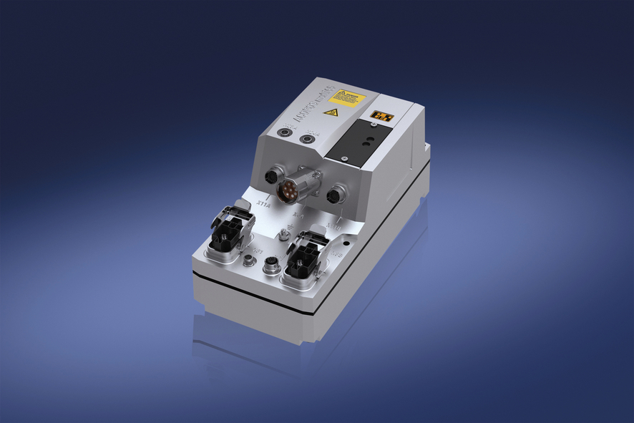
The ACOPOSmulti65 inverter for applications where the drive is mounted directly on the machine makes flexible machine configurations possible.

关于贝加莱
贝加莱是一家总部位于奥地利并在全球拥有分公司的创新型自动化企业。2017年7月，贝加莱成为ABB集团的机械自动化事业部。作为工业自动化领域的全球领导者，贝加莱将前沿技术与领先工程相结合，为几乎每个行业的客户提供面向机器与工厂自动化、运动控制、HMI和集成安全技术的完整解决方案。借助于OPC UA、POWERLINK、openSAFETY等工业物联网通信标准，以及强大的Automation Studio软件开发平台，贝加莱不断重新定义自动化工程的未来。受简化流程和超出客户预期的承诺驱动，贝加莱始终保持创新精神并处于工业自动化领域的前沿。
获取更多信息，请访问www.br-automation.com。

