The easy integration of Stäubli robots using uniVAL drives and POWERLINK networks
Robots from Stäubli can now be directly operated with B&R controllers. This is possible thanks to a POWERLINK interface on Stäubli's uniVAL drives that allows Generic Motion Control programs from B&R controllers to be transferred to the robots. In this way, robotics engineers can use the uniform programming and operating environment provided by B&R controllers.
Robots are connected to the network using POWERLINK, the real-time Ethernet standard. When using a higher-level controller, the controllers for the Stäubli robots are switched into passive mode, which still allows them to check whether incoming control commands are valid with regard to kinematics and safety.
The uniform operating interface means that system operators can save time, money and work during commissioning and servicing. For machine manufacturers, the reduction in interfaces doesn't just mean a lower selling price, but also shorter cycle times in production, cutting costs there as well.
In addition, the shared POWERLINK network also offers fully uniform diagnostic support as well as the ability to implement comprehensive solutions – from the visualization application and motion/robot control all the way to integrated quality control via image processing in a hard real-time network.

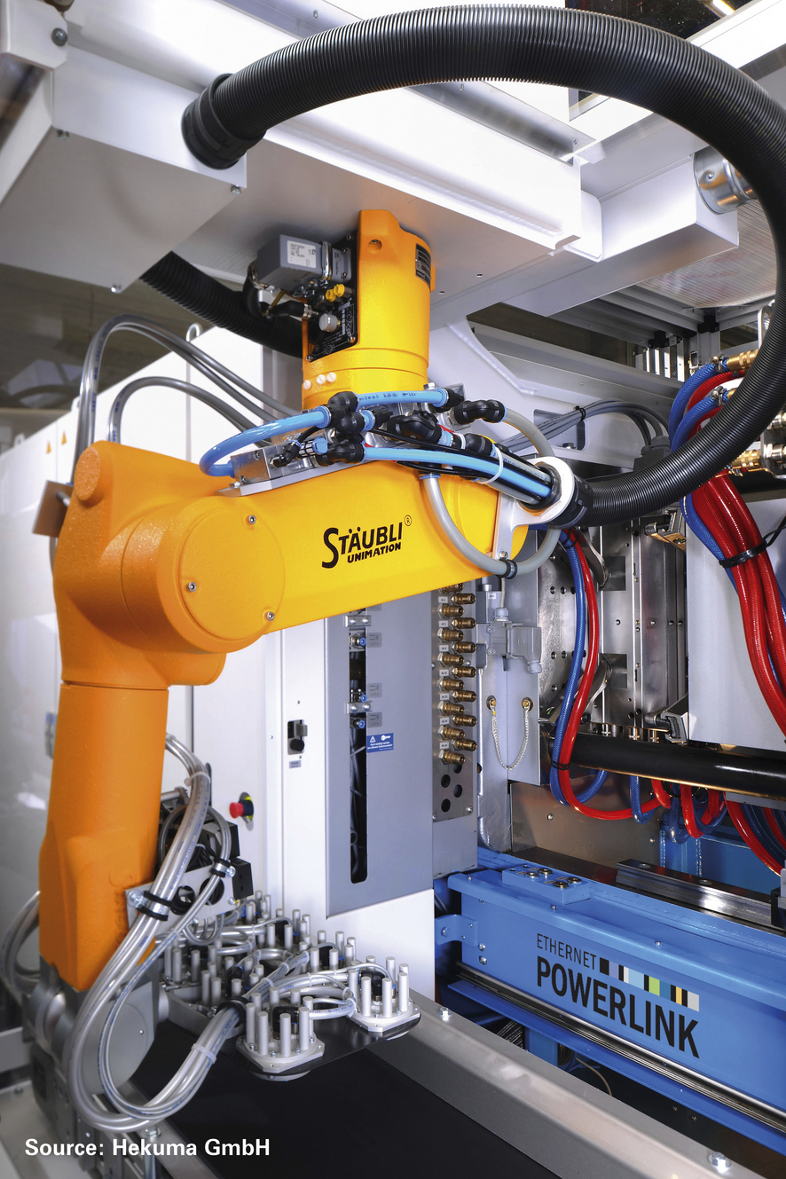
The Stäubli robots are connected to the network using POWERLINK, the real-time Ethernet standard.

About B&R
B&R, a division of ABB Group, is a global leader in industrial automation headquartered in Austria. B&R combines state-of-the-art technology with advanced engineering to provide customers in virtually every industry with complete solutions for machine and factory automation, motion control, HMI and integrated safety technology. With Industrial IoT communication standards including OPC UA, POWERLINK and openSAFETY as well as its Automation Studio software, B&R is constantly redefining the future of automation engineering. The innovative spirit that keeps B&R at the forefront of industrial automation is driven by a commitment to simplifying processes and exceeding customer expectations.
For more information, visit www.br-automation.com.

