The easy integration of Stäubli robots using uniVAL drives and POWERLINK networks
Robots from Stäubli can now be directly operated with B&R controllers. This is possible thanks to a POWERLINK interface on Stäubli's uniVAL drives that allows Generic Motion Control programs from B&R controllers to be transferred to the robots. In this way, robotics engineers can use the uniform programming and operating environment provided by B&R controllers.
Robots are connected to the network using POWERLINK, the real-time Ethernet standard. When using a higher-level controller, the controllers for the Stäubli robots are switched into passive mode, which still allows them to check whether incoming control commands are valid with regard to kinematics and safety.
The uniform operating interface means that system operators can save time, money and work during commissioning and servicing. For machine manufacturers, the reduction in interfaces doesn't just mean a lower selling price, but also shorter cycle times in production, cutting costs there as well.
In addition, the shared POWERLINK network also offers fully uniform diagnostic support as well as the ability to implement comprehensive solutions - from the visualization application and motion/robot control all the way to integrated quality control via image processing in a true real-time network.

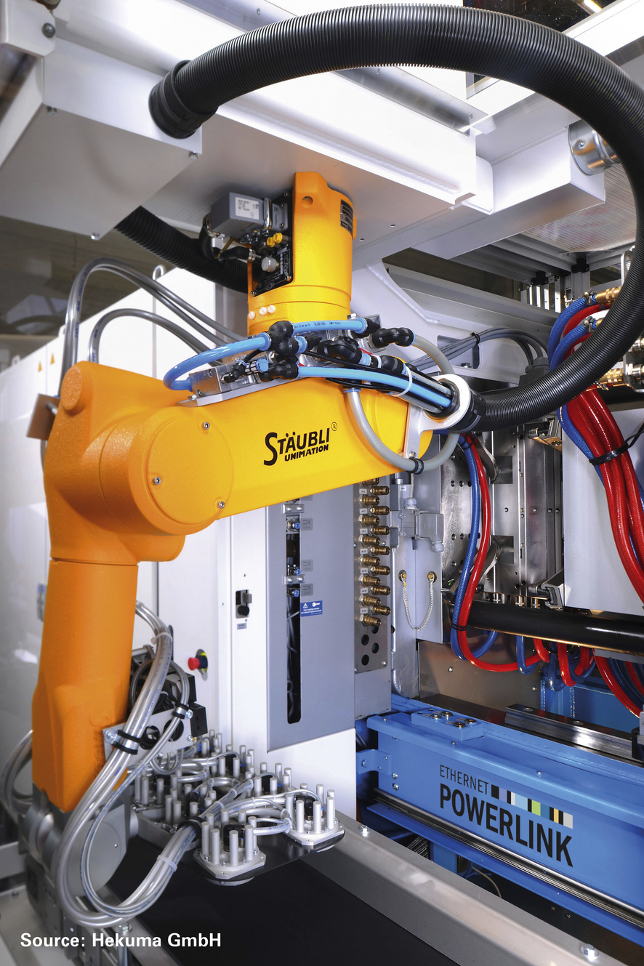
The Stäubli robots are connected to the network using POWERLINK, the real-time Ethernet standard.

关于贝加莱
贝加莱是一家总部位于奥地利并在全球拥有分公司的创新型自动化企业。2017年7月，贝加莱成为ABB集团的机械自动化事业部。作为工业自动化领域的全球领导者，贝加莱将前沿技术与领先工程相结合，为几乎每个行业的客户提供面向机器与工厂自动化、运动控制、HMI和集成安全技术的完整解决方案。借助于OPC UA、POWERLINK、openSAFETY等工业物联网通信标准，以及强大的Automation Studio软件开发平台，贝加莱不断重新定义自动化工程的未来。受简化流程和超出客户预期的承诺驱动，贝加莱始终保持创新精神并处于工业自动化领域的前沿。
获取更多信息，请访问www.br-automation.com。

