Advanced system diagnostics via the Web
With the latest version of the System Diagnostics Manager (SDM), B&R has added a range of powerful new diagnostic functions to an already impressive portfolio. The user profits not just from being able to access information about system hardware and software from anywhere in the world, but also from ready-made diagnostic applets that can be easily integrated directly into applications.
Since all service functions necessary for a machine or system are already integrated in the System Diagnostics Manager, it can be launched from any PC without any installation whatsoever. The only requirement is a conventional Web browser. The appearance of the System Diagnostics Manager can also be individually customized to match the look and feel of the machine or systems manufacturer using it.
Many different diagnostic options
In addition to being able to quickly access current drive values – for example, speed, position, enable status or the status of onboard inputs – the axis error list also provides information in table form about errors that are still pending as well as those that have already been acknowledged. SDM can also be used to easily access and operate drive-integrated oscilloscopes. Being able to check the current status of I/O channels on every bit of hardware with an integrated I/O viewer means that machine and system commissioning is easier than ever. The time-consuming process of testing I/O points using electrical wiring is now a thing of the past.
System dump makes support even easier
During servicing, all data in the System Diagnostics Manager can be loaded from the controller and saved to a file with a simple click of the mouse. This makes it possible for difficult service cases to be analyzed offline by a 2nd level support team. For machine manufacturers, this opens up totally new dimensions for handling maintenance and service claims.

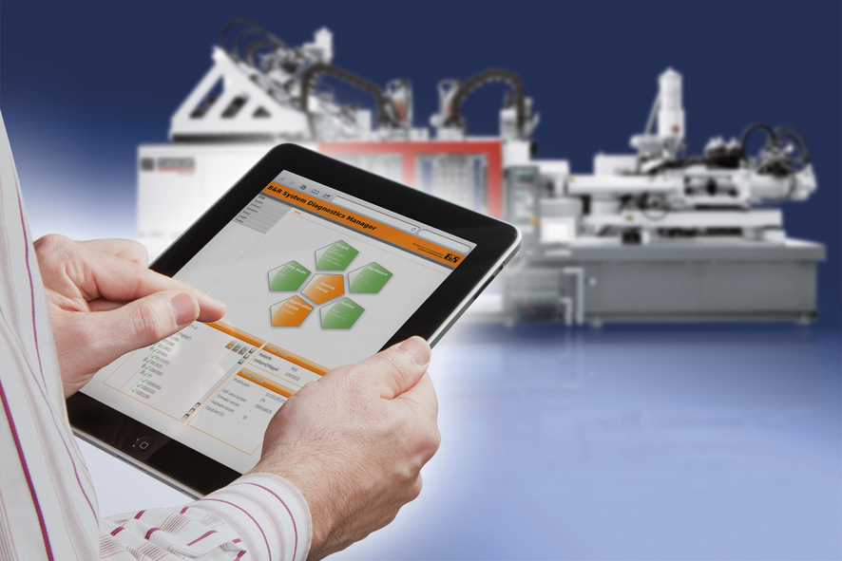
Based on the B&R real-time operating system, this new tool allows seamless system diagnostics from any location (intranet or Internet) using any Web browser.

About B&R
B&R, a division of ABB Group, is a global leader in industrial automation headquartered in Austria. B&R combines state-of-the-art technology with advanced engineering to provide customers in virtually every industry with complete solutions for machine and factory automation, motion control, HMI and integrated safety technology. With Industrial IoT communication standards including OPC UA, POWERLINK and openSAFETY as well as its Automation Studio software, B&R is constantly redefining the future of automation engineering. The innovative spirit that keeps B&R at the forefront of industrial automation is driven by a commitment to simplifying processes and exceeding customer expectations.
For more information, visit www.br-automation.com.

