Evolving ergonomics with multi-touch
In the area of consumer electronics, multi-touch has not only changed the ergonomics of devices, it has changed user habits as well. In industrial automation, this technology has the potential to make machine operation more intuitive, faster and safer – in essence, bringing about a revolution in ergonomics for machine and system visualization units. At the SPS/IPC/Drives exhibition in Nuremberg, B&R introduced devices that allow multi-touch input in industrial environments.
For over a decade there has been a strong and consistent trend towards touch screens in industrial automation solutions. They have even broken through in a big way in industries such as foodstuffs and pharmaceuticals where hygiene plays such an important role. "Touch screens are not likely to completely replace devices with physical keys," explains Raimund Ruf, manager of the HMI Business Unit at B&R. "Nevertheless, they will continue to advance into more and more areas due to their overall versatility. At the same time, we are seeing much more emphasis being placed on user ergonomics, both in how panel hardware is arranged as well as in the design of the user interface."
Two-finger ergonomics
The multi-touch technology we are familiar with from smartphones – which can detect and evaluate the presence of two or more points of contact with the screen at the same time – offers the next big leap in innovation in the field of machine manufacturing.
This technology promises a significant increase in usability by simplifying operation while increasing the level of safety at the same time. Operations where one hand is used to open up a menu while the other sets parameters are definitely a possibility. This would eliminate the need to jump back and forth between sub-menus while increasing overall clarity in the application. The operator is able to get where he needs to go faster through the elimination of complex menu layers. Navigating lists can also be simplified by allowing the operator to simply scroll through the content instead of having to rely on narrow scrollbars. Operational safety can also be increased by implementing methods such as blocking certain actions until an additional button is pressed simultaneously with the other hand. Even if this doesn't completely replace dead-man's controls just yet, multi-touch operation used in this way can still prevent critical operating steps from being carried out unintentionally.
Product presentation at the SPS/IPC/DRIVES trade fair
B&R presented their own multi-touch technology at the SPS/IPC/DRIVES fair in the form of a 21.5" Full HD Automation Panel for mounting on a swing arm. Its solid glass surface makes it easy to clean and offers the operator excellent haptic properties.

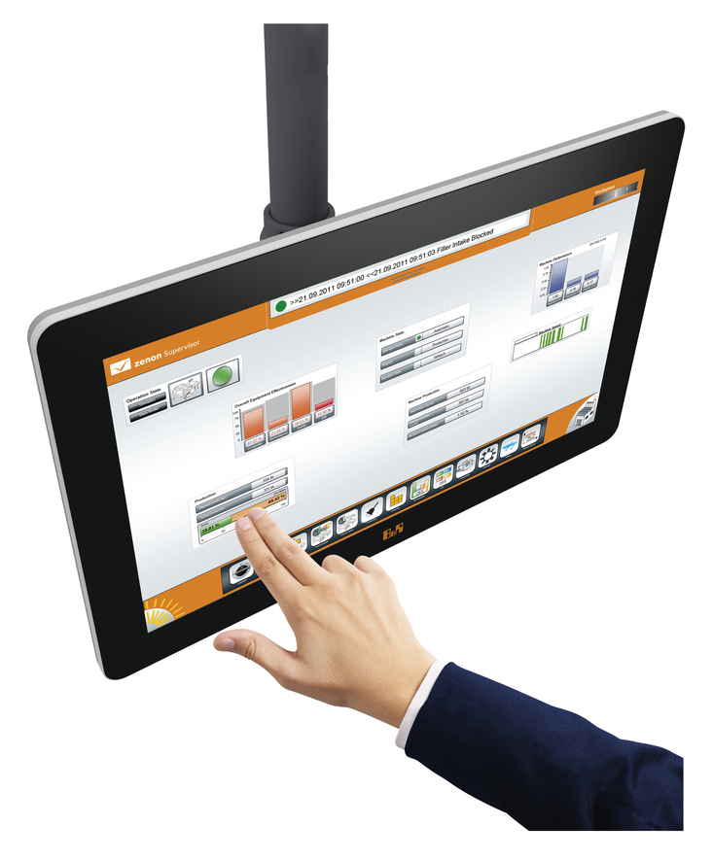
21.5" Full HD touch screen from B&R

About B&R
B&R, a division of ABB Group, is a global leader in industrial automation headquartered in Austria. B&R combines state-of-the-art technology with advanced engineering to provide customers in virtually every industry with complete solutions for machine and factory automation, motion control, HMI and integrated safety technology. With Industrial IoT communication standards including OPC UA, POWERLINK and openSAFETY as well as its Automation Studio software, B&R is constantly redefining the future of automation engineering. The innovative spirit that keeps B&R at the forefront of industrial automation is driven by a commitment to simplifying processes and exceeding customer expectations.
For more information, visit www.br-automation.com.

