Evolving ergonomics with multi-touch
In the area of consumer electronics, multi-touch has not only changed the ergonomics of devices, it has changed user habits as well. In industrial automation, this technology has the potential to make machine operation more intuitive, faster and safer - in essence, to bring about a revolution in ergonomics for machine and system visualization units. At the SPS/IPC/Drives exhibition in Nuremberg, B&R introduced devices that allow multi-touch input in industrial environments.
In industrial automation, there has been a strong and consistent trend towards touch screens for over a decade. They have even broken through in a big way in hygiene-related industries such as foodstuffs and pharmaceuticals. "Touch screens are not likely to completely replace devices with physical keys," explains Raimund Ruf, manager of the HMI Business Unit at B&R. "Nevertheless, they will continue to advance into more and more areas due to their overall versatility. At the same time, we are seeing much more emphasis being placed on user ergonomics, both in how panel hardware is arranged as well as in the design of the user interface."
Two-finger ergonomics
The multi-touch technology we are familiar with from smartphones - which can detect and evaluate the presence of two or more points of contact with the screen at the same time - offers the next big leap in innovation in the field of machine manufacturing.
It promises a significant increase in usability by simplifying system operation while increasing the level of safety at the same time. Operations where one hand is used to open up a menu while the other sets parameters setting are definitely a possibility. This would eliminate the need to jump back and forth between sub-menus while increasing overall clarity in the application. The operator is able to get where he needs to go faster because complex menu layers can be eliminated. Handling lists would also be simplified since the operator could simply scroll through the content instead of having to rely on narrow scrollbars.
Operational safety can also be increased by implementing methods such as blocking certain actions until an additional button is pressed simultaneously with the other hand. Even if this doesn't completely replace dead-man's controls just yet, multi-touch operation used in this way can still prevent critical operating steps from being carried out unintentionally.
Product presentation at the SPS/IPC/DRIVES trade fair
B&R presented their own multi-touch technology at the SPS/IPC/DRIVES fair in the form of a 21.5" Full HD Automation Panel for mounting on a support arm. Its solid glass surface makes it easy to clean and offers the operator excellent haptic properties.

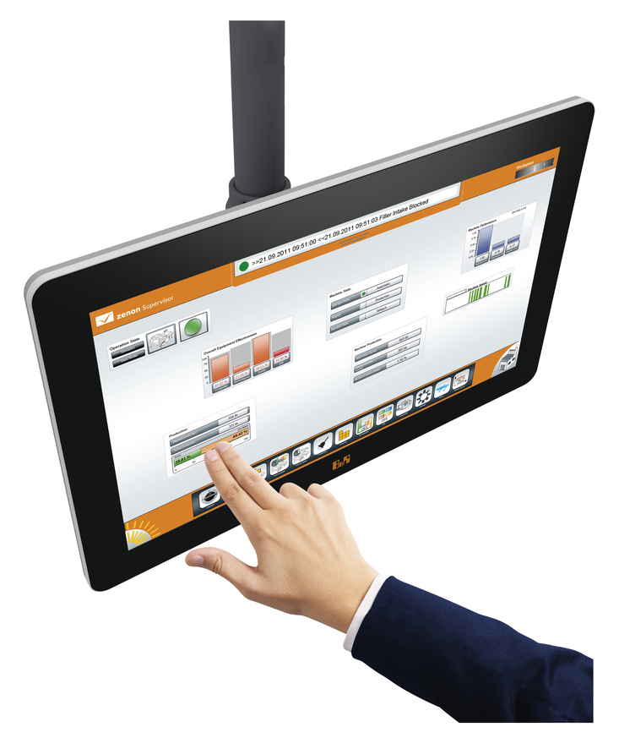
21.5" Full HD touch screen from B&R

Acerca de B&R
B&R, empresa perteneciente al Grupo ABB y con sede en Austria, es líder mundial en automatización industrial. B&R combina tecnología de vanguardia con ingeniería avanzada para proporcionar a usuarios de todos los sectores soluciones completas para la automatización de máquinas y fábricas, Motion Control, HMI y tecnología de seguridad integrada. El catálogo de productos se completa con estándares de comunicación de IoT industrial que incluyen OPC UA, POWERLINK y openSAFETY. Gracias a su única herramienta de software Automation Studio, B&R redefine constantemente el futuro de la ingeniería de automatización. El espíritu innovador que mantiene a B&R a la vanguardia de la automatización industrial está impulsado por el compromiso de simplificar los procesos y superar las expectativas de los clientes.Para más información, visite www.br-automation.com.
Para más información, visite www.br-automation.com.

