Evolving ergonomics with multi-touch
In the area of consumer electronics, multi-touch has not only changed the ergonomics of devices, it has changed user habits as well. In industrial automation, this technology has the potential to make machine operation more intuitive, faster and safer - in essence, to bring about a revolution in ergonomics for machine and system visualization units. At the SPS/IPC/Drives exhibition in Nuremberg, B&R introduced devices that allow multi-touch input in industrial environments.
In industrial automation, there has been a strong and consistent trend towards touch screens for over a decade. They have even broken through in a big way in hygiene-related industries such as foodstuffs and pharmaceuticals. "Touch screens are not likely to completely replace devices with physical keys," explains Raimund Ruf, manager of the HMI Business Unit at B&R. "Nevertheless, they will continue to advance into more and more areas due to their overall versatility. At the same time, we are seeing much more emphasis being placed on user ergonomics, both in how panel hardware is arranged as well as in the design of the user interface."
Two-finger ergonomics
The multi-touch technology we are familiar with from smartphones - which can detect and evaluate the presence of two or more points of contact with the screen at the same time - offers the next big leap in innovation in the field of machine manufacturing.
It promises a significant increase in usability by simplifying system operation while increasing the level of safety at the same time. Operations where one hand is used to open up a menu while the other sets parameters setting are definitely a possibility. This would eliminate the need to jump back and forth between sub-menus while increasing overall clarity in the application. The operator is able to get where he needs to go faster because complex menu layers can be eliminated. Handling lists would also be simplified since the operator could simply scroll through the content instead of having to rely on narrow scrollbars.
Operational safety can also be increased by implementing methods such as blocking certain actions until an additional button is pressed simultaneously with the other hand. Even if this doesn't completely replace dead-man's controls just yet, multi-touch operation used in this way can still prevent critical operating steps from being carried out unintentionally.
Product presentation at the SPS/IPC/DRIVES trade fair
B&R presented their own multi-touch technology at the SPS/IPC/DRIVES fair in the form of a 21.5" Full HD Automation Panel for mounting on a support arm. Its solid glass surface makes it easy to clean and offers the operator excellent haptic properties.

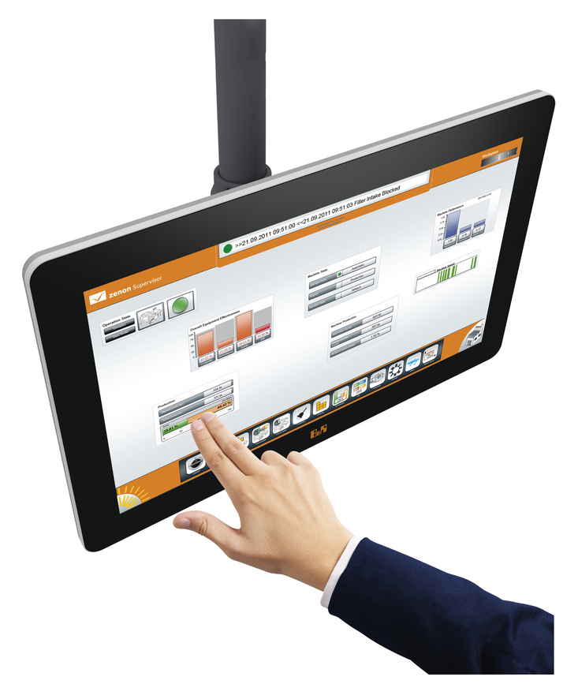
21.5" Full HD touch screen from B&R

关于贝加莱
贝加莱是一家总部位于奥地利并在全球拥有分公司的创新型自动化企业。2017年7月，贝加莱成为ABB集团的机械自动化事业部。作为工业自动化领域的全球领导者，贝加莱将前沿技术与领先工程相结合，为几乎每个行业的客户提供面向机器与工厂自动化、运动控制、HMI和集成安全技术的完整解决方案。借助于OPC UA、POWERLINK、openSAFETY等工业物联网通信标准，以及强大的Automation Studio软件开发平台，贝加莱不断重新定义自动化工程的未来。受简化流程和超出客户预期的承诺驱动，贝加莱始终保持创新精神并处于工业自动化领域的前沿。
获取更多信息，请访问www.br-automation.com。

