B&R sponsord practical instruction
Active learning is extremely important at the elementary school in Eggelsberg. For this reason, we wanted to do our part by making a donation in cooperation with the "education highway" initiative sponsored by Upper Austria. Our donation made it possible to provide the school with a "Technikbox", a collection of hundreds of chemistry and physical science experiments that presented new classroom learning opportunities for the children – something that makes principal Annemarie Stegbuchner very happy. With the "Technikbox", students can develop and carry out their own experiments while collecting valuable technical experience along the way. "Kids at this age in particular are extremely hungry for new knowledge and are very open to new ideas," said Stegbuchner. "The experiments included in the 'Technikbox' provide us with another avenue for underpinning learning by demonstrating the practicality of the acquired knowledge."
It's not just the teachers who benefit from the extra support in the classroom; the experiments themselves are fun, which adds to the students' enjoyment. "It is very important to arouse the child's interest in things like natural science and chemistry at an early age," said Franz Enhuber, director of the B&R Automation Academy. "We made this donation because we want to help children discover their own talents for understanding technical interrelationships."

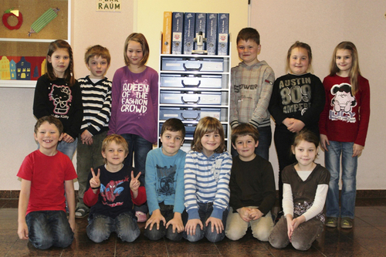
The students at Eggelsberg's elementary school are pleased with the new "Technikbox". It allows them to learn about science independently by conducting experiments in the fields of physics and chemistry.

B&R Hakkında
ABB Grubunun bir bölümü olan B&R, merkezi Avusturya'da bulunan endüstriyel otomasyon alanında global bir liderdir. B&R, neredeyse her sektördeki müşterilere makine ve fabrika otomasyonu, hareket kontrolü, HMI ve entegre güvenlik teknolojisi için eksiksiz çözümler sunmak üzere en son teknolojiyi ileri mühendislikle birleştiriyor. OPC UA, POWERLINK ve openSAFETY gibi Endüstriyel IoT iletişim standartlarının yanı sıra Automation Studio yazılımıyla B&R, otomasyon mühendisliğinin geleceğini sürekli olarak yeniden tanımlıyor. B&R'ı endüstriyel otomasyonun ön saflarında tutan yenilikçi ruh, süreçleri basitleştirme ve müşteri beklentilerini aşma taahhüdünden kaynaklanmaktadır.
Daha fazla bilgi için www.br-automation.com adresini ziyaret edin.

