B&R sponsord practical instruction
Active learning is extremely important at the elementary school in Eggelsberg.For this reason, we wanted to do our part by making a donation in cooperation with the "education highway" initiative sponsored by Upper Austria.Our donation made it possible to provide the school with a "Technikbox", a collection of hundreds of chemistry and physical science experiments that presented new classroom learning opportunities for the children – something that makes principal Annemarie Stegbuchner very happy.With the "Technikbox", students can develop and carry out their own experiments while collecting valuable technical experience along the way."Kids at this age in particular are extremely hungry for new knowledge and are very open to new ideas," said Stegbuchner. "The experiments included in the 'Technikbox' provide us with another avenue for underpinning learning by demonstrating the practicality of the acquired knowledge."
It's not just the teachers who benefit from the extra support in the classroom; the experiments themselves are fun, which adds to the students' enjoyment. "It is very important to arouse the child's interest in things like natural science and chemistry at an early age," said Franz Enhuber, director of the B&R Automation Academy. "We made this donation because we want to help children discover their own talents for understanding technical interrelationships."

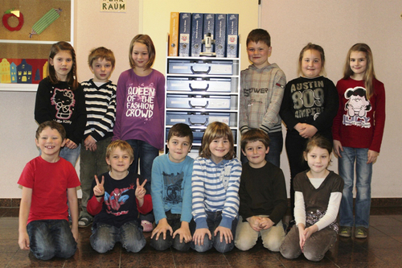
The students at Eggelsberg's elementary school are pleased with the new "Technikbox". It allows them to learn about science independently by conducting experiments in the fields of physics and chemistry.

关于贝加莱
贝加莱是一家总部位于奥地利并在全球拥有分公司的创新型自动化企业。2017年7月，贝加莱成为ABB集团的机械自动化事业部。作为工业自动化领域的全球领导者，贝加莱将前沿技术与领先工程相结合，为几乎每个行业的客户提供面向机器与工厂自动化、运动控制、HMI和集成安全技术的完整解决方案。借助于OPC UA、POWERLINK、openSAFETY等工业物联网通信标准，以及强大的Automation Studio软件开发平台，贝加莱不断重新定义自动化工程的未来。受简化流程和超出客户预期的承诺驱动，贝加莱始终保持创新精神并处于工业自动化领域的前沿。
获取更多信息，请访问www.br-automation.com。

